**PRIMARY SEVEN ENGLISH**

**Topic1: School Holidays**

**Vocabulary**

**Mini dictionary**

**Holiday:** a period of time when someone is not at school or place of work.

|  |  |
| --- | --- |
|  | \**School children usually for the holidays at the end of every term.* |
| **Travel:** | to go from one place to another over a long distance. |
|  | \**I enjoy travelling by train.* |
| **plan:** | an arrangement or to think a way of doing something. |
|  | \**It is good for one to plan for one’s holidays*. |

**Break off:** to end

\**We shall break off for holidays next month.*

**Prepare:** to arrange, organize or get ready for something \**School children must always prepare for holidays*.

**Vacation:** a very long holiday or one of the periods of time when one is away from

school, college or university.

* ***My cousin spent his primary seven vacation in the village.***

**Relatives:** members of your family.

* ***We should always visit our relatives in holidays***.

**Pen-pal:** Someone you become friendly with by writing letters.

* ***My elder brother’s pen-pal lives in Canada***. **Commence:** to start or begin.

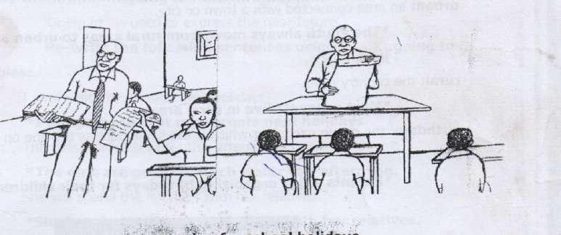

**Preparing**



**for school holidays**



.



***The second term’s holidays will commence in August***.

**Programme**: a list or a series of planned activities.

***Holiday makers should have clear programmes***.

**Remedial classes**: Classes intended to make an improvement or to correct or help

|  |  |
| --- | --- |
|  | slower learners. |
|  | ***Weak learners ought to have remedial classes every evening***. |
| **End**: | To conclude. |
|  | ***The holidays ended peacefully***. |
| **Board**: | to get on a bus, train, plane or ship. |
|  | ***The passengers are waiting to board but to Kigali***. |

**Up-country**: An area which is not near large towns.

***Most game parks in Uganda are located up-country***.

**Town**: A place with many buildings where people live and work.

***A town is smaller than a city***.

**Urban**: an area connected with a town or city.

***The youth always move from rural areas to urban areas to look for jobs***. **Rural**: the country side.

***Most peasants live in rural areas***.

**Birthday**: the day in each year which is the same date as the one which you were born. ***Parents enjoy organizing birthdays for their children***.

**EXERCISE**

(a) **Fill in the blank space with a suitable word**.

1. He travelled ............................... bus from Nairobi to Kampala.
2. The pupils will break .............................. for holidays very soon.
3. The third term’s holiday is longer ............................ the first term’s holiday.
4. You will visit your relatives next holiday, ........................................ you?
5. The village ............................... we spent out holidays was full of fruits and vegetables.

(b) **Use the correct form of words in the brackets to complete the sentences**.

1. I ............................... going to visit my grandparents next month (to be)
2. We enjoyed the birthday at the .................................... (begin)
3. She ................................... the last holiday in Sudan. (spend)
4. Pupils go .......................................... during the holidays. (swim)
5. It is good to spend your holiday.................................... (wise)
6. Peter visited his grandmother ................................. last year. (two)
7. The third term holiday is ..................................... of the three. (long)
8. The girls ................................. their parents while the boys were playing football. (help)
9. I enjoy ............................................. to the village by car. (travel)
10. It was such an interesting ..................................... that everyone enjoyed it. (vacate)

**Language structures.**

**(a) ........................... going to .......................**

‘Going to’ is used to express the near future.

Rewrite the following sentences using ................... going to .....................

**Examples**:

1. I shall visit my parents next holidays.

***I am going to visit my parents next holidays.***

1. The girls will fetch water this afternoon.

***The girls are going to fetch water this afternoon.***

1. She will spend the holidays with her relatives.

***She is going to spend the holidays with her relatives*.**

**EXERCISE**

**Re-write the following sentences using ........... going to .................**

1. We shall revise our books during the holidays.

_____________________________________________________________________________

1. You will spend your holiday in Nigeria.

______________________________________________________________________________

1. The headteacher will address the pupils before they break off for holidays

______________________________________________________________________________

1. I shall enjoy my brother’s birthday party.

______________________________________________________________________________

1. Nambi will travel to Kigali next holiday.

_____________________________________________________________________________ 6. They will write to their pen-pals next week.

_____________________________________________________________________________ 7. The children will go to the zoo next weekend.

_____________________________________________________________________________

8. He will help his parents on the farm tomorrow.

_____________________________________________________________________________

(b) **Question tags**:

A question tag normally comes at the end of a sentence or statement.

We use a question tag at the end of a sentence or statement in order to change a question and express politeness.

**Note**:

1. A question tag may be made up of the following helping verbs, do, does, can, will, shall, were, did have etc.
2. A question tag always consists of a pronoun e.g. I, she, he, you, they, it, we, etc.
3. We use a negative question tag after an affirmative or positive statement.

**Examples**:

i. Mary will spend her holiday here, won’t she? ii. You will go to the village next week, won’t you? iii. We shall pass the examination, shan’t we?

4. A positive question tag is used after negative statement.

**Examples:**

i. Mary will not spend her holiday here, will she? ii. You will not go the village next week, will you? iii.

We shall not pass the examination, shall we?

5. After let’s ................. the question tag is .................... shall we?

i. Let us go for holidays, shall we? ii.

Let’s help our parents, shall we?

6. In requests and after the imperative Do /Don’t do....................................... Etc, the tag is usually ......................... will you?

**Examples**.

1. Revise your books, will you?
2. Open the classroom, will your? iii. Listen to the announcements, will your?

**EXERCISES**

**Complete the following sentences with the correct question tag**.

1. We are going for holidays next month, .....................................?
2. They will do well at the farm, .........................................?
3. I am not going for holidays, ..........................................?
4. Let’s go swimming now, ...................................?
5. You have eaten two eggs, ................................?
6. She sings well, ...............................................?
7. I shall not help you, ............................................?
8. Open the suit case, .....................................?
9. Listen to the teacher’s advice, ..........................................?
10. He did not attend the birth day party, .............................................?

C. **Direct and reported speech**.

**Re-write the following sentences in reported speech.**

**Examples**:

**Direct**:

1. “Where are you going to spend your holidays Jane?” The headteacher asked.

**Reported speech**: The headteacher wanted to know from Jane where she was going to spend her holidays.

**Direct**:

1. ‘Will you help your parents, Tom?” asked his friend.

**Reported speech**: Tom’s friend asked him if he would help his parents. **Direct**:

1. “I am going for holidays now,” said Joyce.

**Reported speech**: Joyce said that she was going for holidays then.

**EXERCISE**

(a) **Rewrite the following sentences in repoted speech**.

1. The pupils said, “ We are going for holidays today,”

______________________________________________________________________________

1. “Why don’t you like travelling by train?” Moses asked David.

______________________________________________________________________________ 3. “I am very busy now, “said the driver.

______________________________________________________________________________ 4. “How far is it from Kampala to Kaseser?” he asked.

______________________________________________________________________________

5. “What is the matter, Cynthia?” asked Mrs. Kabanda.

______________________________________________________________________________

B. **Rewrite the following sentences in direct speech**.

1. The class teacher advised the pupils to spend their holidays wisely.

_____________________________________________________________________________

1. The young boy said that he was sick. _____________________________________________________________________________ 8. Mrs. Njoroga said that she would spend her holidays in Kenya.

_____________________________________________________________________________ 9. He said that he was tired.

_____________________________________________________________________________

10. The doctor asked me what the matter was.

_____________________________________________________________________________ **D. Active and passive voice.**

The sentence in active voice begins with the subject whereas in the passive voice the sentence begins with the object.

**Note**: (a) The voices change according to the tense used.

(b) The main verb in the passive voice is used in past participle form, e.g. gone, seen, helped etc.

**Examples:**

**Change the following sentences to passive voice**.

1. Active: The boys play football during the holidays. Passive: Football is played during the holidays by the boys.
2. Active: My children eat a lot of food in the holidays. iii. Active: Tom helps me.

Passive: I am helped by Tom

**EXERCISE**

(a) **Change the following sentences into passive voice.**

1. The girls sweep the classroom every evening.

______________________________________________________________________________ 2. My parents feed me during the holiday.

______________________________________________________________________________

1. Biko eats mangoes every day.

______________________________________________________________________________  **(b) Change the following sentences into active voice.**

1. News papers are read during the holiday by them.

______________________________________________________________________________ 5. The programme is written by the secretary.

______________________________________________________________________________

6. The camp is organized by the teacher.

______________________________________________________________________________

**Passage.**

**Read the passage and answer the questions in full sentences.**

**Going for school Holidays**.

There are three terms in a year. At the end of every term, school children break off for holidays. School holidays are the happiest and funniest moments in school life. School holiday give pupils’ time to relax, plan and visit their relatives and friends in urban or rural areas. Of the three holidays, the third term’s holiday is the longest. This is because I last for two months or sixty days. The first term’s and second term’s holidays last for about three to four weeks.

During holidays, children get change to help their parents on the farm with garden work or with house chores at home. Holidays also provide children with ample time to learn new skills such as knitting, weaving, modelling, baking and looking after domestic animals. They also enable children to **prepare** for the next term.

Sometimes children tour places of their interest such as game parks, zoos, museums, historical sites, mountains and forest. In addition, children for camping with their peers. On some occasions religious leaders organise retreats for the youth during holidays. This gives the youth a platform to meet people from all walks of life and share ideas and acquire new knowledge.

Dear children, it is good to plan for your holidays, never waste your holidays gossping or playing cards.

**QUIDING QUESTIONS**

(a) What happens at the end of every term?

_______________________________________________________________________________ (b) How does the writer describe school holidays.

_______________________________________________________________________________

(c) Which holiday is the longest?

_______________________________________________________________________________ (d) How do good students spend their holidays?

_______________________________________________________________________________

1. Give another word or group of words with the same meaning as underlined word in the passage;

Prepare__________________________________________

1. Mention any one skill a holiday maker is likely to acquire in holidays.

_______________________________________________________________________________ **Guided composition**:

**The sentence below are not in their proper order. Re-arrange them so that they form a good composition about “School holidays”**

1. However, resting does not simply mean being idle or not working at all.
2. They may also include visiting relatives and friends during this period.
3. Since this would be very difficult to fulfil when we are at school.
4. It only means doing activities that help your body and mind to relax.
5. That is why we should always have holidays at the end of every term.
6. Why do you think so?
7. Most pupils believe that this period is indeed very good for us.
8. Such activities include camping, swimming and touring important places.
9. I think so because holidays enable us to rest.
10. Every school child needs a holiday.

_____________________________________________________________________________

_____________________________________________________________________________

_____________________________________________________________________________

_____________________________________________________________________________

_____________________________________________________________________________

_____________________________________________________________________________

_____________________________________________________________________________

_____________________________________________________________________________

_____________________________________________________________________________

_____________________________________________________________________________

_____________________________________________________________________________

_____________________________________________________________________________

_____________________________________________________________________________

_____________________________________________________________________________ _____________________________________________________________________________ **SUB-TOPIC 1B: HOLIDAY ACTIVITIES.**

**Vocabulary:**

**Mini Dictionary**:

**Study**: to learn about something by reading.

Our cousin will study medicine when he joins Nkumba University.

**Farm**: A place where crops, fish or animals are bred or to use a piece of land for growing crops and keeping animals.

*Olanya’s grandfather has a large farm in Mpigi district.*

**Tour**: A journey made for pleasure.

*We shall tour Mombasa harbour in the holiday*.

**Camp**: A place where young people go on holiday so as to take part in various activities.

*The P.7 Candidates spent a week at camp last holidays*.

**Visit**: To stay somewhere for a short time or to go and see somebody.

*Peter usually visits his grandmother in the December holidays*. **Begin**: To start doing something.

*The first term holiday will begin in April*.

**Concert**: A public performance of music.

*I sometimes attend concerts in the holiday.*

**Show**: A theatre performance.

*Babirye and Kato watched an interesting show last weekend*.

**Cook**: To prepare food or a person who prepares food.

*Girls help their parents to cook food in the holidays*.

**Revise**: To prepare for an examination by reading or going through one’s notes.

*Joseph spent the last holiday revising for his examinations*.

**House work**: The activities or duty involved in taking care of a home.

*Washing and cooking are good examples of house work.*

**Trip**: A short journey to a place for pleasure.

*The holiday makers had a trip to Mombasa last December*.

**Enjoy**: To be happy and get pleasure from something.

*School children always enjoy their holidays*.

**Nice**: Something enjoyable, attractive or pleasant. *My elder brother had a nice holiday in the village*.

**Interesting**: Something that attracts you attention because it is unusual or exciting.

*It was such an interesting journey that everyone enjoyed it.*

**Exciting**: Causing great excitement or interest.

*Swimming in the afternoon is very exciting*.

**Report**: A written statement about a pupil’s work and conduct at school.

*School children get reports at the end of every term*.

**Vacation**: A very long holiday or one of the periods of time when one is away from school, college or university.

*Ruth will work in a super market during her P.7 vacation.*

**Chores**: Tasks that one does regularly.

*It is good to spend one’s holidays doing domestic chores.*

**Routine**: The normal way or order in which one regularly does things. *Cleaning and mopping the house is a daily routine*.

**Bash**: A large party or celebration.

*My parents organized a birthday bash in the holiday*.

**Fare**: The money which you pay to travel by plane, bus or taxi. *School children usually travel at half fare*.

**EXERCISE**

(a) **Use the correct form of the words in the brackets to complete the sentences.**

1. Babirye ............................. her parents every morning. (greet)
2. The girls ............................ water while the boys were playing football. (fetch)
3. The farmers in our village ............................... plant their crops during the rainy season. (usual)
4. Mary goes ............................... every holiday. (to camp)

(b) **Re-write the following sentences as instructed.**

1. It is bad to play cards during the holiday. (Begin: Playing............................)

_______________________________________________________________________________ 6. “I will work hard next term,” said Bruno. (Begin: Bruno said that...........)

_______________________________________________________________________________

1. It was a very nice holiday. (Begin: What............................!)

_______________________________________________________________________________

1. Peter did not enjoy the holiday. Dumba did not enjoy the holiday.

(Begin: Neither.......nor.......)

____________________________________________________________________________________

____________________________________________________________________________________

1. We got our report cards before we went for holidays.

(Re-write using........................ after..........)

_____________________________________________________________________________

1. I was sick but I enjoyed the holiday. (Begin: Even though.........................)

_______________________________________________________________________________ **Language structures:**  **(a) Participle tense:**

|  |  |
| --- | --- |
| **Verb** | **Past participle** |
| break | broken |
| weave | woven |
| take | taken |
| tell | told |
| hold | held |
| sing | sung |
| begin | begun |
| dig | dug |
| help | helped |
| sow | sown |
| sew | sewn |
| sweep | swept |
| visit | visited |
| study | studied |
| fetch | fetched |
| dirty | dirtied |
| eat | eaten |
| drink | drunk |
| drive | driven |
| ride | ridden |
| see | seen |
| sell | sold |
| burst | burst |
| cut | cut |
| clean | cleaned |
| mop | mopped |
| meet | met |
| freeze | frozen |
| flee | fled |
| revise | revised |
| copy | copied |
| leave | left |

**EXERCISE**

**Complete the following sentences using the past participle form to the verb in the brackets**.

1. The new term has ...................................... very well. (begin)
2. I haven’t ........................................ my grandmother since last holiday. (see)
3. We reached the bus park when the bus had ................................. (leave)
4. By mid-day the water in the fridge had .................................... (freeze)
5. She has .................................... a lot of water from the well. (fetch)
6. All my clothes were ............................................. during the holidays. (tear)
7. The village choir has ............................................ a nice song. (sing)
8. The school bus is .............................................. by an old man. (drive)
9. Have you ever ................................................ your grandparents? (visit)
10. By the time we wet to bed, grandmother had ............................... us an interesting story. (tell)

**(b) If 3 Conditional.**

If 3, is used to express what would have happened if a certain condition had been fulfilled. We use the pas perfect tense in the if clause and would, could, might, should /+ have and a past participle verb in the main clause.

|  |  |
| --- | --- |
| **If clause** | **Main clause** |
| If + had + a past participle verb          e.g. If I had seen him in the holiday. If we had gone to the village. | Would have + a past participle verb Should have + a past participle verb. Could have + a past participle verb Might have + a past participle verb.    He would have given me some money.  We would have seen our grandparents. |

**Note**: He can be used to start an IF 3 sentence when IF is left out or omitted.

**Examples**:

i. Had I seen him in the holiday, he would have given me some money. ii. Had we gone to the village, we would have seen our grandparents.

When the main cause is in negative form, we use the grammatical order below.

* would not have
* could not have
* should not have
* might not have

**E**.**g**. If Mary had helped her parents; they would not have punished her. If they have boarded the first bus, they might not have reached late.

**Written Exercise 1B. 3**

**(a) Use the correct form of the words in brackets to complete the sentences.**

1. If you........................... your holidays, you would have visited your parents. (to get)
2. Had she come early, we .................................. with her. (travel)
3. If we ................................. our notes, we should have passed the examination. (revise)
4. I................................ with him If I had known. (go)
5. Peter ............................. his holidays in New York if he had got a visa. (spend)

(b) **Change the following sentences into IF3**

1. If I go to the village, I will meet my relatives.

_______________________________________________________________________________

1. If Jane writes to me, I will reply.

______________________________________________________________________________ 8. Tendo will visit her grandmother if she gets the bus fare.

______________________________________________________________________________ 9. If you see her, she will take you for holidays.

______________________________________________________________________________

10. I did not revise my notes so I failed the examinations.

______________________________________________________________________________ **Guided composition.**

**The sentences below are in a wrong order. Re- arrange them in the correct order to make a good composition about “Nakku goes back to school”**

1. He parents therefore organized a small party to bide her farewell.
2. She sat close to the window so as to see the beautiful scenery on the way.
3. The school holidays had finally ended.
4. As soon as the train set off, Nakku began to feel sleepy.
5. She dreamt that the school holidays had finally ended.
6. Early the next day, Nakku went to the railway station to board a train to school.
7. Nakku was to go back to school the following day.
8. Nakku invited some of her friends to the party.
9. As she slept, she stated dreaming.
10. They danced throughout the night.

_____________________________________________________________________________

_____________________________________________________________________________

_____________________________________________________________________________

_____________________________________________________________________________

_____________________________________________________________________________

_____________________________________________________________________________

_____________________________________________________________________________

_____________________________________________________________________________

_____________________________________________________________________________

_____________________________________________________________________________

_____________________________________________________________________________

_____________________________________________________________________________

_____________________________________________________________________________

Below is the holiday programme for Mr. and Mrs. Kigoye’s sons and daughters. Study it carefully and answer the questions in full sentences

|  |  |  |
| --- | --- | --- |
| **Name of the**  **Holiday**  **maker** | **Day** | **Activity** |
| Kato | Saturday | Making bricks |
| Lydia | Sunday | Attending prayers |
| Brenda | Monday | Shopping/ preparing lunch |
| Gladys | Tuesday | Fetching water /baking cakes |
| Wasswa | Wednesday | Collecting fire wood from the forest. |
| Kato | Thursday | Weeding the banana plantation. |
| Lydia | Friday | Looking after cattle. |
| Brenda | Saturday | Watching cartoons on T.V |
| Gladys | Sunday | Visiting relatives |
| Wasswa | Monday | Helping mother in the shop |
| Kato | Tuesday | Washing clothes and utensils. |
| Lydia | Wednesday | Touring the zoo Camping at Kaazi |

a) How many children does Mr. Kigoye have?

_________________________________________________________________________________ b) What is the table about?

_________________________________________________________________________________

1. Which child works a lot on Wednesday?

_________________________________________________________________________________

1. Where do you think Wasswa will collect the firewood from?

_________________________________________________________________________________

1. On which day is Lydia likely to watch cartoons on TV?

_________________________________________________________________________________

1. What does Kato do on Thursday?

_________________________________________________________________________________

1. Which child is likely to see wild animals?

_________________________________________________________________________________

1. From which child do we expect some building materials?

_________________________________________________________________________________

1. Which meal does Brenda prepare on Monday?

_________________________________________________________________________________

1. Who is expected to bake a birthday cake?

_________________________________________________________________________________

**Guided composition:**

**Below is a conversation about how Kiiza** **and Tony spend their holiday**. Complete it by filling in the missing parts.

Kiiza: Good afternoon, Tonny.

Tony: (i) ..........................................................................................................................................

Kiiza: How do always spend your holidays?

Tony: (ii) .........................................................................................................................................

Kiiza: Helping your parents in the shop? Is it a retail or wholesale shop?

Tony: (iii) ........................................................................................................................................

Kiiza: What device do you use to measure wheat flour and sugar in your shop?

Tony: (iv) ........................................................................................................................................

Kiiza: A weighing scale! How much does a kilo of wheat flour cost?

Tony: (v) .......................................................................................................................................

Kiiza: Four thousand shillings only! That’s expensive.

Tony: What about you Kiiza, how do you always spend your holidays?

Kiiza: (vi) .......................................................................................................................................

Tony: Visiting relative and touring important places! Do you usually travel alone?

Kiiza: (vii) .......................................................................................................................................

Tony: With your parents! How do you sometimes travel to Kasese?

Kiiza: (Viii) ......................................................................................................................................

Tony: By train! For how long do you stay at your grandmother’s home?

Kiiza: (ix) ........................................................................................................................................

Tony: A fortnight! Goodbye, Kiiza

Kiiza: (x) .........................................................................................................................................

**TOPIC 2: LETTER WRITING.**

**SUB-TOPIC 2A: INFORMAL LETTERS. VOCABULARY:**

**MINI- dictionary**

**Address:** The details of where somebody lives or works and where letters can be sent. *My pen-pal gave me her address and telephone number*.

**First name**: The name which was given to you when you were born which comes before your family name.

*Her first name is Grace and her surname is Namusoke*.

**Personal**: Your own or belonging to you.

*A personal letter is different from an official letter*.

Personal letter: A letter that is written or sent to an individual.

*I wrote a personal letter to Uncle George.*

Informal letter: A friendly letter that is written to one’s relatives or friends.

*Informal letters and different from formal letters*.

**Stamp**: A small piece of paper with a design on it which you buy and stick on an envelope per parcel.

May I have two stamps, please?

Envelope: A flat paper container in which letters are sealed and sent somewhere. Having written a letter, I bought an envelope.

|  |
| --- |
|  |

Envelope

**Occasion**: A special ceremony or celebration.

*Tom’s birthday party was a memorable occasion.*

**Party**: A feast or social occasion.

*Our school organizes children’s party every year*.

**Affectionately**: In away showing feelings and love for somebody.

*I ended the letter which I wrote to my aunt with yours affectionately*.

**Sincerely**: In a way that shows what one really feels or thinks about somebody.

We must sincerely apologise whenever we misbehave at school.

**Yours sincerely**: Used at the end of a letter before you sign your name for example when you address somebody by their name.

*Whenever you address somebody in a letter by their name, you must end with* ***yours*** *sincerely***.**

**Relatives**: Members of your family.

*Teddy’s relatives live in Masaka town.*

**Friends**: People you like and who like you too.

*Your cousin is good at making new friends*.

**Classmates**: People with whom you are or were in the same class at school.

*She usually writes to her classmates*.

***Informal introduction***: Beginning which is not official or formal.

*Personal letters sometimes have an informal introduction.*

**Body**: The message one wishes to convey to the receiver in a letter.

*Informal letters, the body comes after the greeting.*

**Date**: A particular day of the moth or year usually given in figures pr words.

*You should not forget the date every time you write a letter.*

**Reply**: To say, write or give an answer to somebody. *Lydia replies to my letter whenever I write to her*.

**Purpose**: The aim or intention of something.

*The purpose of this letter is to invite you to my wedding*.

**Reason**: A cause or an explanation for something which has happened or that has been done.

*I don’t know the reason why you don’t reply to me*.

**Inform**: To tell someone about something.

*Just in case you change the address, you must inform us*. **Ask**: To request.

*If you ask her, she will inform him*.

**Thank**: to tell someone that you are grateful for what they have done.

*We must sincerely write and thank our class teacher for teaching us letter writing.*

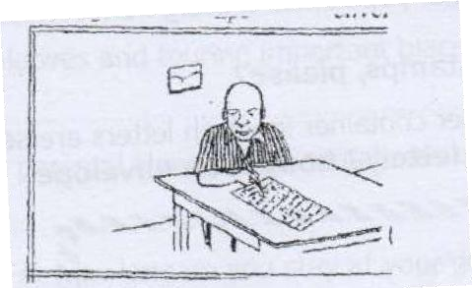

**EXERCISE**

**Use the correct form of the words in the brackets to complete the sentences.**

1. Suzan is ............................... to write to me tomorrow. (like)
2. The letter was .................................. to the headteacher. (address)
3. I ................................ a personal letter now. (write)
4. Joseph received a ................................ a letter yesterday. (person)
5. Whenever I post a letter, I pay the........................................ fee. (Post)
6. Jane ended the letter to her aunt with yours............................................... (affection)
7. The ................................................ tells us what some body is writing about. (introduce)
8. When you address somebody by their name, you may

end with yours.......................... (sincere)

1. She...................................... writes to me informal letters. (usual)

**Language structure:**

(a) **............................ is likely to ...............................**

**Re-write the following sentences using .................... is likely to ......................**

**Examples**

1. Judith may write to me next week.

**Judith is likely to write to me next week.** 2. I may post these letters tomorrow.

**I am likely to post these letters tomorrow**

3. They may visit the post office next week.

**They are likely to visit the post office next term.**

**EXERCISE**

**Re-write the following sentences using ...........is/are or am likely to .................**

1. Anna may write to the headteacher tomorrow.

_________________________________________________________________________________ 2. Many people may apply for the post advertised.

_________________________________________________________________________________ 3. Robert may reply to my letter soon.

_________________________________________________________________________________ 4. The headmaster may invite our parents to a meeting.

_________________________________________________________________________________

5. The post master may deliver the letters today.

_________________________________________________________________________________

(b) **............................ hardly......................**

**Re-write the following using .......................hardly ........................**

**Examples**

1. There is almost nobody who has bothered to apply for the job.

***There is hardly anybody who has bothered to apply for the job.***

1. There was no one at the post office. ***There was hardly anyone at the post office.***

1. There isn’t any stamp on the envelope.

***There is hardly any stamp on the envelope.***

**Written exercise 2a.3;**

**Re-write the following sentences using ..............hardly.....................**

1. There was almost no letter in the mailbox.

_________________________________________________________________________________

1. There isn’t anyone at the reception.

_____________________________________________________________________________

1. There was nobody at the main gate.

_________________________________________________________________________________ 4. There is almost nobody who has bothered to reply.

_________________________________________________________________________________

5. I haven’t written any letter.

_________________________________________________________________________________ **Writing informal letters.**

**Parts of an informal letter.**

1. The writer’s address. e.g. Army primary school

P.O.Box 18,

Nakasongola

1. Date e.g. 16th March 2023

16-03-2023

March 16, 2023.

N.B: The date is written below the writer’s address

1. Greeting e.g. Hello cousin,

Dear Daddy,

Dear Mum, etc.

1. **Body or message**.

The body contains the message the write intends to convey or send to the receiver. E.g.

I hope you are fine. I am just writing to say happy birthday to you.

* Thank you very much for your letter which I received last week.
* I am writing to invite you to my birthday party which is going to take place next week etc.

1. **Ending / Conclusion**.

You may use any of the following endings in informal letters.

* + - your loving cousin
    - yours sincerely,
    - Your best friend,
    - Your loving daughter,
    - Yours affectionately,
    - Your granddaughter,
    - Your grandson,  Your nephew,  Your niece etc.

1. **The writer’s name**.

**e**.g. Nafula Agnes.

Abdul Kiiza etc.

**Methods of writing informal letters**.

There are two methods used in writing letters nowadays. These are;

1. Block method.
2. Indent method.

**a) Block method**

Tororo Junior school,

P.O.Box 3,

Tororo

March 16th, 2023

Dear Flavia,

Thank you very much for your letter which I received yesterday. I was indeed pleased to learn that you won the letter writing competition in our school last term.

Congratulations. I kindly invite you to my sister’s wedding ceremony which will take place next Saturday.

Please send my greetings to your parents, sisters and brothers.

Yours loving friend, Matovu Francis.

**b) Indent method**

Katwe Primary School,

P.O.Box 10,

Kampala

16th March, 2023

Hello Mike,

Let me hope you are alright. I have written this letter to invite you to my brother’s graduation party. The party will take place on Saturday 28th April, 2023 at our home in Busunju. The function will begin at 3:00pm.

Yours affectionately

Namuganga Maggie

**Comprehension**:

Hormisdallen school, Gayaza

P.0.Box 30223 kampala

1st February, 2023

Dear Suzan,

Thank you for your letter which was full of news. It is quite interesting to note that the farmer in Kigezi use terrace to control soil erosion.

In your letter you wanted to know how cattle keepers in my home district care for their animals. Well, the cattle keepers in Mbarara keep long-horned cattle for milk and meat production. They take them to the fields to graze every day. Funny enough, even girls and women look after cattle. This activity keeps them out of home from morning to dusk.

The cattle herders wear sandals to guard their feet against thorns and sharp stones. They also carry roasted cassava and water to eat while in the fields.

Sometimes, the cattle stray and destroy crops. When this happens, the owner of the cattle pays fine.

It is my hope that I have answered your question. Once more, thank you for replying to my letter. Please send my regards to your family. God bless you.

Yours sincerely,

Kyagante Alvin

1. In which district does the writer of this letter live?

_______________________________________________________________________________

1. To whom was the letter addressed?

_______________________________________________________________________________

1. Where do farmers use terraces to control soil erosion?

_______________________________________________________________________________

1. Why do cattle herders wear sandals?

_______________________________________________________________________________

1. When do cattle keepers pay fine?

_______________________________________________________________________________

1. On which date was the letter written?

_______________________________________________________________________________ g) Who wrote the letter?

_______________________________________________________________________________

1. What do the cattle herders carry with them according to the letter?

_______________________________________________________________________________

1. What do girls and women in the writer’s district?

_______________________________________________________________________________

1. Why do farmers keep cattle?

_______________________________________________________________________________

**Letter writing**:

You are organizing to celebrate your twelfth birthday. Using your school address, write a letter to your cousin inviting him/her to your birthday party. In your letter tell him/her the date, place and the time the function will begin and end. Tell him/her some of the items on the programme.

**Use the words in the box below to complete this letter.**

Gayaza primary school.

P.O.Box 310,

Kasangati

..................................................

Hullo ..........................................

How are you over there? How is your class teacher? I hope you are preparing for the

Primary Leaving .................................. By the way, where did you put your first .....................? I have written this letter to ......................... you to our school Album launch which will be held in August.

The ................................ will take place at Theatre Labonita. The ....................of honour is expected to be the Minister of Education and .............................................

Please ............................. soon to confirm your coming. I will be very glad to host you.

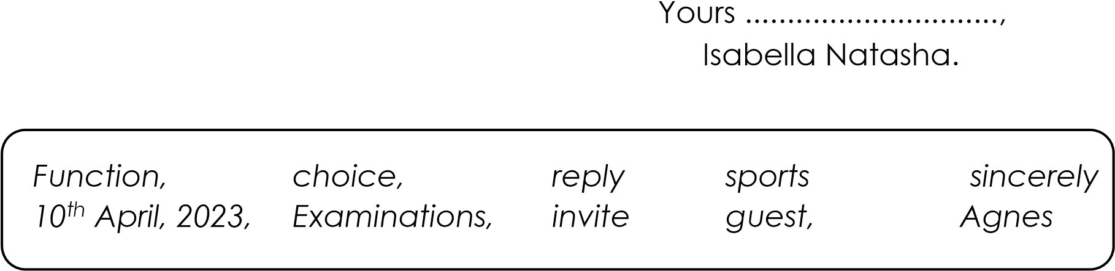

**Guided composition**.

**The sentences below are not in the correct order. Re-arrange them to form a short composition about “A letter to a cousin**”

1. Secondly, she wrote the date.
2. Then she fixed a postage stamp on the envelope.
3. One day, Birabwa wrote a letter to her cousin.
4. Having sealed the envelope, she addressed the letter to her cousin.
5. Finally, she posted the letter and returned home.
6. After the conclusion, she put the letter in an envelope and sealed it.
7. She concluded the letter with her name.
8. After writing the date, she wrote the greeting as “Dear Cousin”
9. First of all, she wrote her address.
10. In addition, she wrote the message that she wanted to convey to her cousin.

________________________________________________________________________________

________________________________________________________________________________

________________________________________________________________________________

________________________________________________________________________________

________________________________________________________________________________

________________________________________________________________________________

________________________________________________________________________________

________________________________________________________________________________

________________________________________________________________________________

________________________________________________________________________________

________________________________________________________________________________

________________________________________________________________________________

________________________________________________________________________________

________________________________________________________________________________ ________________________________________________________________________________

________________________________________________________________________________

**Guided composition**.

**Below is a conversation between Edith and Toto. Read it carefully and fill in what you think Edith said**.

Toto: Good afternoon, Edith.

Edith: 1 ..........................................................................................................................................

Toto: Where are you going?

Edith: 2 ..........................................................................................................................................

Toto: To the post office! What are you going to do there?

Edith: 3 .........................................................................................................................................

Toto: To buy stamps and post a letter! From which post office are your going to buy the

stamps?

Edith: 4 ..........................................................................................................................................

Toto: Luwum street post office! Is it far from here to the post office?

Edith: 5 ..........................................................................................................................................

Toto: By the way, how much does each stamp cost?

Edith: 6 ..........................................................................................................................................

Toto: Fifty shillings only! What else do you need to post a letter?

Edith: 7 ..........................................................................................................................................

Toto: Postage fee! How is the postage fee charged?

Edith: 8 ..........................................................................................................................................

Toto: You mean to say it depends on the mileage or weight of the letter or parcel. Do you mind posting my letter, too?

Edith: 9 .........................................................................................................................................

Toto: I will be very grateful if you post it for me. I wish you a safe journey, Edith.

Edith: 10 .......................................................................................................................................

**Picture composition.**

The pictures A to F tell a story. Study them carefully and then write one sent describe what is happening in each picture.

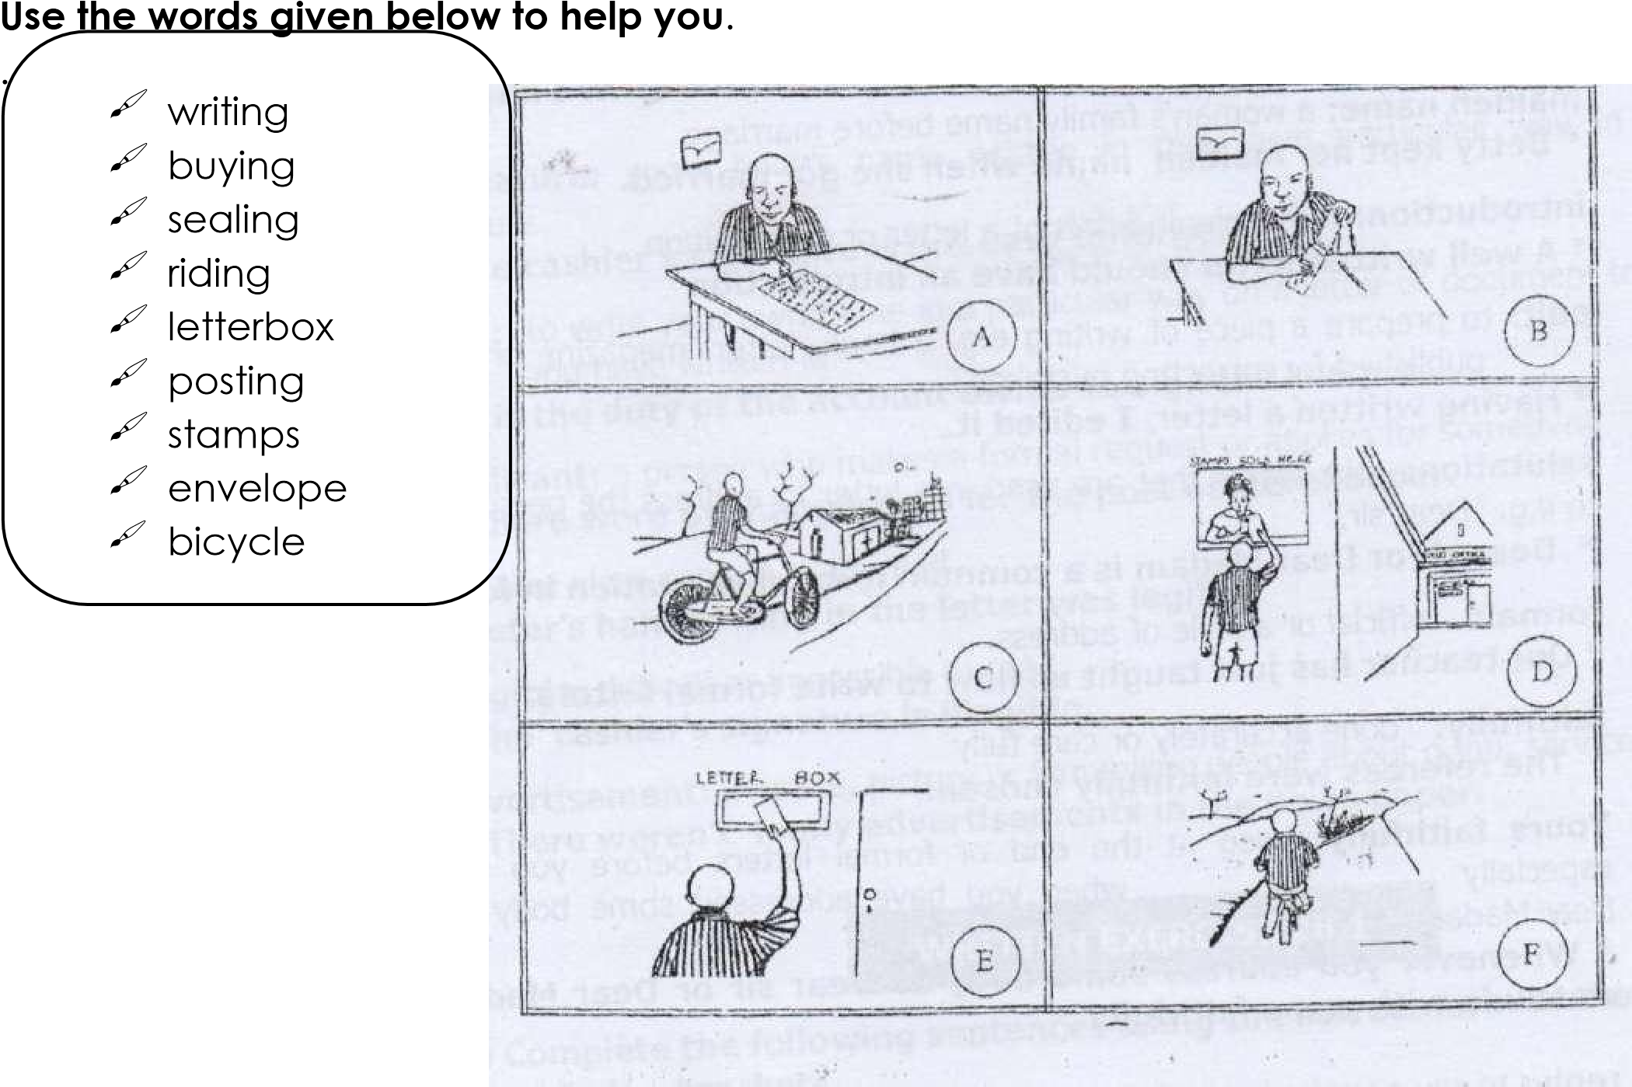

1. Picture A .............................................................................................................................
2. Picture C .............................................................................................................................
3. Picture E ..............................................................................................................................
4. Picture B ..............................................................................................................................
5. Picture D .............................................................................................................................
6. Picture F...............................................................................................................................
7. Where did the boy go after posting the letter?

___________________________________________________________________________________ h) What is the boy doing in picture D?

___________________________________________________________________________________ i) Give a title to this story.

___________________________________________________________________________________

**SUB-TOPIC 2: FORMAL LETTERS**.

**VOCABULARY:**

**MINI- DICTIONARY**

**Formal address**: letters that are usually written to office bearers e.g. headteacher, managers etc.

*A formal letter is different from an informal letter*.

**Surname**: A name which is shared by all the members of a family.

*My name is Kazibwe*

**Maiden name**: A woman’s family name before marriage.

*Betty kept her maiden name when she got married*.

**Edit**: To prepare a piece of writing e.g. a book, letter, magazine, or newspaper to be published by correcting mistakes.

*Having written a letter, I edited it*.

**Salutation**: The words that are used in a letter to address the person you are writing to e.g. “Dear sir,

*Dear Sir or Dear Madam is a common form of salutation in formal letters*. **Formal:** Official or a style of address.

*Our teacher has just taught us how to write formal letters*.

**Faithfully**: Done accurately or carefully.

*The referees were faithfully chosen*.

**Yours faithfully**: Used at the end of formal letters before you sign your name especially when you have addressed somebody as “Dear sir or Dear Madam.”

*Whenever you address some body as Dear sir or Dear Madam, you must conclude with your faithfully*.

**Reply**: To say or write back to somebody.

*Every time relatives write to you, you must reply*. **Vacancy**: A place.

*All candidates will apply for vacancies in senior one*.

**Application**: A formal request for something such as a job, vacancy service, goods or permission.

*Jonah’s application for a vacancy in senior one was addressed to the head teacher*  *of Budo S.S*.

**Reference:** A heading or title of an official letter.

*The short form or reference is Re’ or ‘Ref’*

**Referee**: A person who give information about some one’s behaviour and ability when

they are applying for a job.

The chairman L.C.1 acted as my referee when applied for a new job.

**Conclusion**: The dosing part of a letter, composition or speech.

In his conclusion, he wrote his signature and name.

Sincerely: In way that shows what you feel or think about somebody or something. I sincerely promise that I shall write to you very soon.

**Yours sincerely**. Used at the end of a letter before you sign your name especially when you address some body by their name.

When I write a letter to my cousin, I end with Yours sincerely”

**Signature**: Some body’s name written in their own particular way in letters or cheques.

*The cashier’s signature is not easy to forge*.

**Sign**: To write your own name in a particular way on a letter or document to show that you have written it.

*It is the duty of the account owner to sign the cheque.*

**Applicant**: A person who makes a formal request or applies for something.

*There were over applicants for the post of store keeper.*

**Legible**. Clear enough to be read.

*Peter’s handwriting in the letter was legible*.

**Illegible**: Difficult or impossible to read.

*The cashier’s signature is illegible*.

**Advertisement**: A notice, picture or film telling people about a job, service or product.  *There weren’t many advertisements in the newspaper*.

**EXERCISE**

(a) Complete the following sentences using the correct form of the words given in the brackets.

1. The headteacher’s .................................. is very tricky. (sign)
2. Jane always writes her letter ....................................... (careful)
3. The new pupils will get their .......................................... letters tomorrow. (admit)
4. Barbara received her ..................................... letter to the party last week. (invite)
5. I ............................ the best pupil in the letter writing completion last term. (to be)
6. The letter was ........................................ to the bank manager. (address)
7. There was only two ......................................... who applied for the job. (apply)

(b) **Re-write the sentences giving the opposite of the underlined words.**

8. My sister can hardly write a formal letter.

_________________________________________________________________________________ 9. It is cheap to post a letter.

_________________________________________________________________________________

10. Tom’s hand writing in the letter was legible.

_________________________________________________________________________________

**Language structures:**

2.2 Barely ....................................

Barely is used in negative sentences.

Barely can be used to replace ‘not’ or almost.

**Examples**

1. Your letter cannot be read. Your letter is barely read.
2. Your handwriting is not legible. Your handwriting is barely legible.
3. There is almost nobody at the post office.

There is barely anybody at the post office.

**Note: Barely can be used to begin sentences.**

**Examples**:

1. Barely 10% of the people applied for the post advertised.
2. Barely had I written a letter when the visitors arrived.
3. Barely 30% of the population can read and write.

**EXERCISE**

**Re-write the following sentences using ...........barely..................**

1. The letter was not legible.

________________________________________________________________________________ 2. My sister is not yet nine years old.

________________________________________________________________________________ 3. Almost 20% of the candidates failed the examination.

________________________________________________________________________________

1. About 50% of the class can write formal letters’

________________________________________________________________________________

1. Our teacher hardly speaks French.

________________________________________________________________________________

1. She had almost finished writing the letter when the post master came.

________________________________________________________________________________

**2.3 Barely had.............. when................**

Barely had ..................when ..............is used in the say way like Hardly had or scarcely had ...................when.............................

**Examples**

1. I wrote a letter. Then I posted it.

Barely had I written a letter when I posted it.

1. Scarcely had she reached the post office when she bought the stamps.

Barely had she reached the post office when she bought the stamps.

**EXERCISE**

**Re-write the following sentences beginning: Barely had ..............when.........**

1. When he got a pen, he wrote a letter.

_________________________________________________________________________________ 2. Hardly had the teacher entered the class when the lesson began.

_________________________________________________________________________________ 3. As soon as the teacher left the class, Kato followed him.

_________________________________________________________________________________ 4. Immediately the lesson ended, everyone clapped.

_________________________________________________________________________________

5. Jane arrived at the post office. She slotted the letter into the mail box.

_________________________________________________________________________________

**Abbreviations**:

An abbreviation is a short form of a word.

Common Abbreviations used in Letter writing.

|  |  |  |
| --- | --- | --- |
| C/o ..........care of |  | Mr.  ......................... Mister |
| Rd........... Road |  | Mrs. .......................  Mistress |
| St ...............Saint / Street |  | Ms. ....................... Miz |
| Co ............... Company |  | B.C .......................  Before Christ |
| Oc................. Officer-in-charge |  | i.e. ......... this is (idest) |
| I.O.U ................. I owe you |  | e.g. ............. exempli  gratia |
| Dr. ................... Doctor |  | etc ............... et cetera |
| Rev. ................. Reverend |  | via................. by way of |
| Prof ................ professor |  | O’clock ....... of the clock |
| Hon ................ Honorable |  | Rtd ................ Retired |
| M.P ................ Member of parliament |  | Maj................ Major |
| E-mail.................... Electronic mail | | Col................. Colonel |

Brig...................... Brigadier Bro............... brother

Ave......................Avenue

Ag ..................... acting

No .................... Number

A/c ............ account

Tel. .................... telephone

C.O.D ...................... cash Post Office

G.P.O .................... General Post Office

P.O. ....................... Post Office

a.m ....................... ante meridiem (before noon)

P.m ...................... Post meridiem (afternoon)

R.I.P .................. Rest in peace

N.B .................... nota bene

w.e.f .................... with effect from viz ..................... namely (videlicet)

**Days of the week**

Sun - Sunday

Mon - Monday

Tue - Tuesday

Wed - Wednesday

Thur - Thursday

Fri - Friday

**Months of the year.**    **Other short forms.**

Jan - January won’t will not

Feb - February can’t can not Mar - March shan’t shall not

Apr - April isn’t is not

May - May don’t do not

Jun - June we’ve we have

Jul - July I’ll I will / I shall

Aug - August I’ve I have

Sept - September Let’s Let us

Oct - October I’m I am

Nov - November I’d I would / I had / I

could Dec - December you’ll you will they’re they are you’re you are didn’t did not aren’t are not hasn’t has not

haven’t have not etc.

**Writing formal letters.**

**Formal letters are the letters that we write to office bears. For example head teachers, managers etc.**

**Reasons why people write letters.**

1. To apply for jobs.
2. To apply or request for vacancies (place) 3. To invite others to functions or ceremonies.
3. To report issues
4. To apologise
5. To express greetings 7. To express greetings.
6. To inform
7. To order for goods or services.

**Parts of a formal letter**.

**1. The writer’s address.**

e.g.

Katwe Primary School.

P.O.Box 10,

Kampala

(Uganda)

Date e.g. 23 – 3- 2023

23rd March, 2023

23/3/2023

March 23, 2023

**2. The addressee’s / receiver’s address**

e.g.

The headteacher,

Bombo High School,

P.O.Box 15,

Bombo

1. **Salutation.**

e.g.

Dear sir........

Dear Madam...........

Dear Dr. .................

Dear Rev ...................

Dear Mr/Miss ...................

If you know the person’s title or name refer to it as Dear Mr. Kizito, Dr. Professor George Kirya etc.

1. **Reference**

An official letter usually has a title or heading. e.g.

Re. Application for a vacancy in senior one

Re. Application for a job

Re. Application for a teaching post

Re. Application for the post of matron / gate keeper etc.

Re. Friendly football match

Re. Apology for coming late

Re. Absence from school etc

1. **Body/message**

The body contains the message of information the writer wishes to send or convey. You may begin your letter in the following ways.

* I humbly apply for a vacancy in senior one in your school.
* I hereby submit my application for the post of gate keeper in your............
* Following your advertisement in the Monitor, Newspaper 1st May, ..........I humbly submit my application in your office for the post of waiter or waitress etc.
* I wish to submit my application to your office requesting you to allow our school to have a friendly debate or football match with your school.
* I hereby request you to grant me permission to leave school at 4:00pm today.

**6. Ending /conclusion**

You can end a formal letter with following words.

Yours faithfully, especially when you use the salutation. Dear

Sir/Madam yours truly, Yours in service,

After that the writer puts his/her signature first then the name is capital letters, e.g. yours faithfully,

Kato Ali

KATO ALI

**Methods of writing letters.**

There are two methods of writing letters. These are;

1. Block method
2. Indent method

**BLOCK METHOD**

Bat valley P/s

P.O.BOX 100, KAMPALA

(UGANDA)

23RD MARCH, 2023

The headteacher,

Railway Primary School,

P.O.Box 11,

JINJA

Dear Sir/Madam,

Re: **FRIENDLY DEBATE**

I humbly request you to allow my school to have a friendly debate with your debating club. Your club can suggest the motion for the debate and whether they would like to propose or oppose the motion.

The debate is proposed to take place 15th April, 2023 in your school main hall at 2:00pm. I would be very grateful if you could allow us to come.

Yours faithfully,

............................

Nakatte Aida

NAKATTE AIDA

CHAIRPERSON DEBATING CLUB

**INDENT METHOD**

BAT VALLEY P/S P.O. BOX 100,

KAMPALA, 23-32023

The Games master,

Nakasero Junior School, P.O.Box 31062, Kampala.

Dear Sir/ Madam,

Re: **FRIENDLY NETBALL MATCH**

I here request you to allow my school to have a friendly netball match with your school The match will take place on 18th April, 2023 at your school playground.

I will be very grateful if you allow us to come.

Your faithfully,

Nakato Rinah

NAKATO RINAH

**EXERCISE**

**Guided composition**

1. The sentences below are in a wrong order. Re-arrange them to make a good composition about “Letter writing”

1. Informal letter is written to relative and friends.
2. In addition, we discussed several reasons why people write letters.
3. Last week, our teacher of English taught use about letter writing.
4. Lastly, people write letters either to apologise or to order for goods and services.
5. One of them is to apply for jobs or vacancies.
6. These are informal and formal letters.
7. While formal letters are written to office bearers.
8. The other is to invite somebody to a function.
9. Such as head teachers, bank managers and District Education Officers.
10. He said, “There are two types of letters.

____________________________________________________________________________________

____________________________________________________________________________________ ____________________________________________________________________________________ ____________________________________________________________________________________ ____________________________________________________________________________________

____________________________________________________________________________________ ____________________________________________________________________________________ ____________________________________________________________________________________

____________________________________________________________________________________ ____________________________________________________________________________________ ____________________________________________________________________________________ ____________________________________________________________________________________

____________________________________________________________________________________

2. Write a letter to the Sales Manager, National Supermarket P.O.Box 15, Kampala, applying for the post of Sales Assistant during your primary seven vacation. You many include you sex and age.

**Guided composition**

**Complete the letter below by filling in the missing parts from the list below**.

Deo Mixed Primary School,

P.O.Box 300,

.............................

27th March, 2012

The Headteacher,

Kamwokya High school,

P.O.............................. 2056

Kampala.

....................................................

**Re. APPLICATION FOR A VACANCY IN SENIOR ONE**.

I humbly submit my application to your office a ....................... in senior one next year. I am a male ...................... aged 13. I hope to ................... for the Primary Leaving Examinations in November this year at the above mentioned school.

My beginning of term examination results were as follows, English 1, Mathematics 1, Science 2, Social studies 2.

Aggregate 6 Division 1

For ................ information about my ............................, if my application is considered.

Yours.........................,

Kisembo Moses.

KISEMBO MOSES



***Words***



*Dear sir,*



*grateful,*



*Kampala,*



*performance,*



*Ugandan,*



*Box,*



*faithfully,*



*more,*



*sit,*



*vacancy.*



**An advertisement**.

Read the advertisement below and answer the questions that follow in full sentences.

|  |
| --- |
| PARA PRIMARY SCHOOL   1. O.BOX 1, KOBOKO     **JOB OPPORTUNITY**  **Job**: Matron  **Age**: Between 24 and 45 years  **Level of Education**: At least Primary Leaving Certificate  **Deadline**: 31st August  **Referees**: 2 referees    Apply to: The Headteacher  Para Primary School  P.O. Box 1  KOBOKO  10- 07- 2023 |

**Questions**:

1. What is the above piece of information called?

______________________________________________________________________________

1. What is the advertisement about?

______________________________________________________________________________

1. Which post was advertised?

______________________________________________________________________________

1. Where was the successful candidate going to work? ___________________________________________________________________________________
2. Who received the applications?

______________________________________________________________________________

1. What was the last day for receiving the applications?

______________________________________________________________________________ 7. What was the minimum qualification required for the job?

______________________________________________________________________________ 8. When was the advertisement written?

______________________________________________________________________________ 9. How old would the applicant be?

______________________________________________________________________________

10. Why do you think Carol a 15-year-old girl could not apply?

______________________________________________________________________________

**TOPIC 3: EXAMINATIONS**

**SUB- TOPIC 3A: PREPARATION FOR EXAMINATIONS VOCABULARY.**

**MINI DICTIONARY**

**Timetable:** A list or chat showing the time at which a particular examination is done. According to the P.L.E time table, Social studies is done in the morning.

**Instructions**: Directions or detailed guidelines on how to do and conduct examinations. During briefing, the headteacher reads the instructions to candidates.

**Signatures:** A signed name.

All candidates must write their signatures on the answer sheets.

**Index number**, a special number that is given to a candidate according to alphabetical order for easy identification.

The index number consists of the school Emis number and a candidate’s number.

**Candidate:** A pupil or person taking or sitting for an examination. Candidates must be checked before entering the examination room.

**School name**: The name of the school where candidate’s studies. Our school name is Hormisdallen schools

**Time allowed**: The official time an examination is meant to take.

The time allowed is usually written on the front page of the questions paper.

**Examiner:** An official or person who sets and marks exams or tests.

UNEB is charged with the responsibility of appointing and training examiners.

**Examinations room:** A special room which is arranged for the candidates who are taking examinations.

The candidates entered the examination room quietly.

**Answer sheet:** A special piece of paper for writing on the answers in an exam. The answer sheets must be tidy.

**Examination centre:** A school or place where candidates or other schools gather to sit their examinations.

Nakasero Primary school is an examination centre for the Primary Leaving Examination

**Briefing**: The act of giving instructions to candidates before taking an examination. The time allowed for briefing is two hours.

**Questions:** Sentences or phrases that call for answers. The first question in the examination was easy.

**Registration:** The act of making an official record of candidates for examinations The candidates did a lot of revision exercises last week.

**EXERCISE**

**Use the correct form of the words in the brackets to complete the sentences.**

(a) Candidates must write their index numbers clearly, (Clear)

1. The .................................... was easy so everybody passed it. (examine)
2. Only ........................candidates will fail this examination. (care)
3. The candidates entered the examination room ............................. (silent)
4. Tom read the ..............................but he didn’t follow them. (instruct)
5. Our class teacher gave us a .............................. exercise last week. (revise)

**(b)Re-write the sentence giving one word for the underlined group of the words**.

1. The pupils who were taking an exam were checked at the entrance.

______________________________________________________________________________ 7. The woman who supervised the examination was very old.

______________________________________________________________________________

8. My uncle is one of the officials who set and mark exams. ____________________________________________________________________________________

9. The candidates did the test without any difficulty.

______________________________________________________________________________

10. James always reads the instructions with care.

______________________________________________________________________________ **Language structures**

**(a) .......................or else................**

**Or else means the same as otherwise.**

Or else is used to warn or advise some one that something bad could happen.

**Re-write the following sentences using: ............................ or else.........**

**Examples.**

i) If you don’t revise your notes, you will fail the examinations.

**You must revise your notes or else you will fail the examinations.**

(ii) If you don’t write clearly, you may lose some marks.

**You must write clearly or else you may lose some marks.**

**EXERCISE**

1. If you don’t write your index number, your results will go missing.

_______________________________________________________________________________ 2. If you don’t keep quiet, I will throw you out of the examination room.

_______________________________________________________________________________

1. If they don’t pay registration fee, you won’t sit for P.L.E

_______________________________________________________________________________

1. If they don’t complete the school fees, they will not be allowed to sit for the

examination.

_______________________________________________________________________________

1. If we don’t work hard, we shall not pass the exams.

_______________________________________________________________________________

**b) .................. look forward to ....................**

“Look forward to” means being optimistic or thinking with pleasure about something that is going to happen.

“Look forward to” or “looking forward to is following by a verb in –ing” form e.g. sitting, meeting, writing, doing, taking etc.

**Re-write the following sentences using......................, look forward to ..........................**

**Example**

(i) We expect to sit for our final examinations.

**We look forward to sitting for our final examinations.**  (ii) I am eager to score four aggregate in PLE.

**I look forward to scoring four aggregate in PLE**

(iii) He is optimistic to join King’s College Budo in senior one.

**He is looking forward to joining King’s College Budo in senior one.**

**EXERCISE**

**Re-write the following sentences using ........... look forward to ................**

1. They expect to fill the UNEB PLE entry forms.

_______________________________________________________________________________ 2. We are eager to pass our final examinations.

_______________________________________________________________________________ 3. She is optimistic to attend the briefing.

_______________________________________________________________________________ 4. I expect to receive my mocks results.

_______________________________________________________________________________

5. You expect to meet the supervisor at the examination centre.

_______________________________________________________________________________

**Guided Composition**.

DO NOT OPEN THIS BOOKLET UNTIL YOU ARE TOLD TO DO SO.

1. This paper has two sections: A and B.
2. Answer all questions. All answers to both sections A and B must be written in the spaces provided.
3. All answers must be written using a blue or black ball-point pen or ink.
4. Unnecessary changes of work may lead to loss of marks.
5. Any handwriting that cannot easily be read my lead to loss of marks.
6. Do not fill anything in the boxes shown. “For examiners Use Only” and those in the questions paper.

**GUIDING QUESTIONS**

(a) Where was the following information extracted?

_______________________________________________________________________________ (b) For which subject are the above instructions? ____________________________________________________________________________________

(c) How many sections does an English examination paper consist?

_______________________________________________________________________________ (d) What will happen to a candidate who writes poorly?

_______________________________________________________________________________ (e) Why do you think a candidate must answer all the questions?

_______________________________________________________________________________ (f) Which body is responsible for setting and marking national examinations in

Uganda?

___________________________________________________________________________________ (g) What does instruction six tell the candidates to do?

_______________________________________________________________________________ (h) Which two instructions are quite similar?

_______________________________________________________________________________

_______________________________________________________________________________

**Jacob is a P.7 candidate and registered to sit for PLE**

**Jacob’s father is a taxi driver. Last week he was imprisoned because he knocked down a pedestrian.**

**Below is a Conversation between Kato and Jacob. Fill in the blank spaces what you think Jacob said**.

Kato: Good morning, Jacob. Jacob: (i)

.......................................................................................................................................................

Kato: How are you, my friend? Jacob:

(ii)

.......................................................................................................................................................

Kato: You are not fine! What is the matter?

Jacob: (iii)

.......................................................................................................................................................

Kato: Why do you think you may miss sitting for the Primary Leaving Examination?

Jacob: (iv)

.......................................................................................................................................................

Kato: You have not paid school fees! Isn’t your father at home? Jacob:

(v)

.......................................................................................................................................................

Kato: Where did your father go?

Jacob: (vi)

.......................................................................................................................................................

Kato: Sorry to hear that. Why was your father imprisoned? Jacob:

(vii)

.......................................................................................................................................................

Kato: Oh! What a pity for your father to have knocked down a pedestrian! Didn’t he leave any money on his bank account?

Jacob: (viii)

.......................................................................................................................................................

Kato: That’s very bad. I advise you to see the headmaster. Jacob:

(ix)

.......................................................................................................................................................

Kato: Yes, I hope he will allow you to sit for the examinations because he is a kind man. Please make sure you see him tomorrow morning. Goodbye, Jacob. Jacob: (x)

.......................................................................................................................................................

**SUB-TOPIC 3B: SITTING EXAMINATION:**

**VOCABULARY**

**MINI-DICTIONARY**

**Pass mark**: A set successful result in an examination.

The pass mark is 75%

**Quality**: A high standard of something.

Uganda National Examinations Board always sets quality examinations.

**Timetable**: A list or chart showing the time at which a particular examination will be done. There are four subjects on the PLE time table.

**Invigilator**: A person who is appointed to watch candidates while they are taking an exam so as to make sure they keep to the rules.

The invigilator must not accept bribes to keep their professional integrity.

**Supervisor**: A person who is appointed to be in charge of an examinations centre and makes sure that exams are done without any malpractice. A supervisor must be a person of high integrity.

**Instructions**: Directions or detailed guidelines on how to do and conduct examinations. A good candidate reads instructions carefully.

**Ink**: Coloured liquid for writing.

All answers must be written in blue or black ball-point or ink.

**Answers**: A reply or response to a question.

All answers to both sections A and B must be written in the spaces provided.

**Marking**: The activity of scrutinizing candidates’ answers and awarding marks. After making the score guide, the examiners started marking.

**Results**: The mark or grade which you get in an examination. The PLE results will be released by UNEB.

**Grades**: Division or marks given in an examination.

Many candidates in our school always get good grades in PLE

**Aggregate**: The total score one obtains in an examination or test. The best candidates in PLE usually get four aggregate.

**Accurate**: Correct and true in every way.

If all your answers are accurate, you will score a hundred percent.

**Percent**: Out of a hundred or one part in every hundred.

Despite the fact that English paper was difficult, Moses scored eight percent.

**Candidate**: A pupil or person taking or sitting for an examination.

Candidates must be thoroughly taught in order to pass their exams.

**Cheat**; To act in a dishonest way so as to score high marks in an exam. Anyone caught cheating the examination, will be disqualified.

**Malpractice**: Cheating or illegal behaviour in an examination.

Copying from one another is a form of examination malpractice.

**Score**: The number of points a candidate gets for correct answers in an exam or test. Whenever you revise your notes, you score high marks in the examination.

**Duration**: The length of the time that an exam lasts.

The duration for the mathematics examination paper is two hours and thirty minutes.

**Examination**: A special test that is given to a candidate to find out how much thye jnow about a subject or for promotion purpose.

The primary leaving examinations are set by UNEB examiners.

**Examiners**: Teachers who set and mark examinations.

The Uganda National Examination Board trains examiners every year.

**Leakage**: Having prior knowledge of something or an examination before the stated time.

All the examination papers were changed due to leakage.

**Work**: A task or to do something.

If you work hard, you will pass the examinations.

**Pass**: To be successful in an exam or test.

My cousin passed the examination because she worked hard.

**Disqualify**: To stop or parent a candidate from doing an examination because of engaging in examination malpractice.

The supervisor told us that my candidate who took part in examination leakage would be disqualified.

**Fail**: Not successful in an exam or test.

Whereas may candidates passed, Ojok failed.

**Pass** **slip**: An official document that shows a candidate’s results in an examination. Our headteacher has not collected the pass slips from UNEB>

**Success**: An achievement.

His success in the examination surprised the teachers.

**Certificate**: An official document providing information that a candidate completed a course of study or passed on examination.

We were given Primary Leaving Examination certificates by the headteacher.

**Division**: A grade

Mr Lutaaya’s son passed in division one.

**EXERCISE**

(a) **Use the correct form of the words in the brackets to complete the sentences.**

1. Olanya’s daughter passed in .............................. two. (divide)
2. Who set this easy ......................................? (examine)
3. Mugisha was a ...................................................candidate. (success)
4. All the candidates were given comfortable .............................(sit)
5. Anyone who fails PLE will not ...............................to join senior one. (disqualify)

(b) **Re-write the sentences giving the opposite form of the underlined word.**

1. My success in the examination surprised my classmates.

_______________________________________________________________________________

1. Tom passed PLE last year.

_______________________________________________________________________________ 8. Your hand writing is really very tidy.

_______________________________________________________________________________

1. The arrival of the supervisor the candidates.

_______________________________________________________________________________

1. Their performance is better than it was last term.

_______________________________________________________________________________

**Language structure:**

**(a) Whereas ......................**

**Examples:**

i. Many candidates passed the examinations. Okello failed the examination.

**Whereas many candidates passed the examinations, Okello failed ii.** Babirye came to school early, Nakato came to school late.  **Whereas Babirye came to school early, Nakato came to school late.**

iii. The English examination paper was easy. The mathematics examination paper was difficult.

**Whereas the English examination paper was easy, the mathematics examination paper was difficult.**

**EXERCISE**

**Re-write the following sentences using: Whereas .........................**

1. The invigilators came early. The supervisor came late.

_______________________________________________________________________________ 2. The candidates but they failed the examination.

_______________________________________________________________________________ 3. My father was a supervisor. My mother was an invigilator.

_______________________________________________________________________________ 4. Wasswa passed the test. Kato failed the test.

_______________________________________________________________________________

5. Kityo scored 90%. Kizito scored 75%.

_______________________________________________________________________________

**b) ........................could..................**

**Examples**.

1. Cheating could lead to closure of the examination centre.
2. Malpractice could lead to disqualification from the examination. iii.

Examination leakage could lead to cancellation of the results. iv. Serious revision could lead to success.

v. Misconduct could lead to expulsion from the examination room.

**c) ...........................in spite of.........................**

Re-write the following sentences using.................in spite of .................... Examples. i. Atim was sick. Atim sat for the examinations.

**Atim sat for the examinations in spite of her being sick. Atim sat for the examinations in spite of her sickness.**  ii. The candidates worked hard. They failed the examination.

**The candidates failed the examination in spite of the fact that they worked hard.**

1. The supervisor rang the bell. The candidates continued to write.

**The candidates continued to write in spite of the fact that the supervisor rang the bell.**

1. He was clever but he did not score 10%.

**He did not score 100% in spite of his being clever. He did not score 100% in spite of his cleverness.**

**EXERCISE**

**Re-write the following sentences using...........in spite of ...........................**

1. Juma was intelligent. He failed the examination.

_______________________________________________________________________________ 2. The candidates came late to school. They were allowed to do the test.

_______________________________________________________________________________ 3. Birabwa failed to pay the registration fees. She sat for the final examination.

_______________________________________________________________________________ 4. The examinations were difficult. The candidates passed all the papers.

_______________________________________________________________________________ 5. Lugoloobi was lazy. He completed the examination in time.

_______________________________________________________________________________

6. The pass mark was high. Zeridah passed in division one.

_______________________________________________________________________________

**D) In spite of .......................**

In spite of can be used to begin a sentence.

Note: A comma is used in the middle when in spite of begins a sentence.

**Re-write the following sentences beginning: In spite of .........................**

1. Agaba was late. She sat for the examinations.

**In spite of her being late, Agaba sat for the examinations.**

1. The candidates worked hard. They failed the examination.

**In spite of the fact that the candidates worked hard, they failed the examination.**

1. Babirye did not pay school fees. She got her pass slip.

**In spite of the fact the Babirye did not pay school fees, she got her pass slip.**

**EXERCISE**

**Re-write the following sentences beginning with: In spite of .................**

1. Tendo was late. She completed her examination on time.

_______________________________________________________________________________

1. It rained heavily. The candidates did their final examination.

_______________________________________________________________________________

1. The candidates paid the registration fees. They did not get their certificates.

_______________________________________________________________________________

1. The pass mark was high. Many pupils passed the mathematics.

_______________________________________________________________________________

1. Diana was lazy, she got a first grade.

_______________________________________________________________________________

1. Ogola was accurate. He scored 75%.

______________________________________________________________________________

**(e) Despite.....................................**

Despite can be used with abstract nouns such as sickness, wisdom, intelligence,

smartness, laziness, cleverness etc.

**Re-write the following sentence beginning: Despite........................................**  **Examples.**

1. Ruth was intelligent. She did not score 100%.
   * **Despite her intelligence, Ruth did not score 100%.**
   * **Despite the fact that Ruth was intelligent, she did not score 100%.**

1. Wilson was late. He finished his examination on time.
   * **Despite his being late, Wilson finished his examination on time.**
   * **Despite the fact that Wilson was late, he finished his examination on time.**

**EXERCISE**

**Re-write the following sentences beginning: Despite.......................**

1. Musana as accurate. He did not score ninety percent.

_______________________________________________________________________________ 2. Kato was young. He did his primary Leaving Examinations.

_______________________________________________________________________________ 3. The supervisor was kind. The candidates did not like him.

_______________________________________________________________________________ 4. The boys were given enough time. They did not complete their examination.

_______________________________________________________________________________ 5. Jackson knew the answers. He did not fill in the blank spaces.

_______________________________________________________________________________

6. Akello was wise, she failed to interpret the questions.

_______________________________________________________________________________

**Passage.**

**Read the passage below and then answer the questions in full sentences**.

It was early in January this year when PLE results 2011 were released. Most candidates became anxious because they wanted to know their results. They therefore sent SMS to 6600.

While releasing the results at Uganda National Examinations Board (UNEB) Headquarters at Ntinda, the Minister of Education and Sports, Hon. Jessica Alup was glad to announce that most of the candidates had passed the examinations.

Besides, the general performance indicated that Science was the best done subject. However, she also noted that Social studies was the worst done subject. The Minister congratulated all the candidates on their success. She also thanked the teachers and head teachers who had taught the candidates and conducted the examinations without any **malpractice**.

Since urban schools performed better than rural schools the minister warned teachers in rural areas against absenteeism, late coming and the high rate of school dropout rural schools. She promised that the Ministry of Education and Sports would come up with a new **policy** very soon.

Finally, the minister called upon headteachers of secondary schools to assemble at Mandela National Stadium at Namboole for selection of successful candidates to secondary schools of their choices.

1. What is the passage about?

_______________________________________________________________________________ 2. Who released the PLE results.

_______________________________________________________________________________ 3. Why were the candidates anxious?

_______________________________________________________________________________ 4. Why was the minister glad to announce PLE results?

_______________________________________________________________________________ 5. In which subject did the candidates perform best?

_______________________________________________________________________________ 6. How many subjects did the candidates sit for?

_______________________________________________________________________________ 7. Which subject was worst done according to the passage?

_______________________________________________________________________________ 8. Give another word or group of words with the same meaning as the following underlined words in the passage.

(i) malpractice _____________________________________________________________________ (ii) assemble ________________________________________________________________________

1. Why do you think Matovu who scored 36 aggregate is likely to repeat P.7?

_______________________________________________________________________________

1. Give a suitable title for this passage.

_______________________________________________________________________________

**Guided composition.**

**The sentences below are in a wrong order. Re-arrange them in the proper order so as to make a good composition about P.7 candidates.**

1. First of all, the parents play their role well.
2. These include textbooks, pens, exercise books, geometry sets and lunch fee.
3. Besides, they give them revision exercises and mark their books regularly.
4. They also give them all the scholastic materials needed.
5. With their hard work and discipline in the end they pass with flying colours.
6. This is by sending their children to school every day.
7. Thirdly, the candidates themselves are disciplined and hard working.
8. Why do some P.7 candidates perform well in their examination?
9. This is really a very interesting question to answer.
10. Secondly, the teachers teach them and cover the syllabus well.

___________________________________________________________________________

___________________________________________________________________________

___________________________________________________________________________

___________________________________________________________________________

___________________________________________________________________________

___________________________________________________________________________

___________________________________________________________________________

___________________________________________________________________________

___________________________________________________________________________

___________________________________________________________________________

___________________________________________________________________________

___________________________________________________________________________

___________________________________________________________________________

___________________________________________________________________________

_________________________________________________________________________

**Study the examination paper and answer the questions in full sentences.**

GULU DISTRICT EXAMINATIONS BOARD

END OF TERM ONE P.7 EXAMINATION 2023

ENGLISH

Time allowed: 2 hours 15 minutes.

|  |  |  |  |  |  |  |  |  |  |
| --- | --- | --- | --- | --- | --- | --- | --- | --- | --- |
|  |  |  |  |  |  |  |  |  |  |

Index No.

Candidate’s Name........................................................................................................... Candidate’s Signature ...................................................................................................

School Name. ...................................................................................................................

District Name....................................................................................................................

**Read the following instructions carefully.**

1. The paper has two sections A and B.
2. Answer all questions. All questions to both sections A and B must be written in the spaces provided.

|  |
| --- |
| For examiner’s use only |
|  |

|  |  |  |
| --- | --- | --- |
| **For examiner’s use of only** | | |
| **Qn.No** |  |  |
| **1-10** |  |  |
| **11-20** |  |  |
| **21-30** |  |  |
| **31-40** |  |  |
| **41-50** |  |  |
| **51-55** |  |  |
| **Total** |  |  |

1. All answers must be written using a blue or black ball – point pen

or ink.

1. Unnecessary changes of work may lead to loss of marks.
2. Any handwriting that cannot be read my lead to loss of marks.
3. Do not fill anything in the boxes shown. For examiner’s use only” and those inside the question papers.

*Gulu District Examinations Board*

**Questions:**

1. Which district set the examinations?

________________________________________________________________________________

1. For which term was the examination?

________________________________________________________________________________ 3. Which class sat for the examination?

________________________________________________________________________________ 4. In which year was the examination done?

________________________________________________________________________________ 5. How can an examiner identify a candidate’s answer sheet?

________________________________________________________________________________ 6. Name the subject paper above?

________________________________________________________________________________

7. How long does this paper last?

________________________________________________________________________________

**OTHER TOPICAL QUESTIONS**

**Comprehension**

Below is a timetable for P.L.E November 2015. Study it carefully and answer the questions about it in full sentences.

**EXAMINATION TIME TABLE FOR P.L.E NOVEMBER 2015.**

|  |  |  |  |  |
| --- | --- | --- | --- | --- |
| **Day &Time** | **Period** | **Time** | **Subject** | **Duration** |
| Tuesday  1st  November | Morning | 9:00am | Briefing of candidate by Headteacher | 2 hours |
| Wednesday | Morning | 9:00am | Social studies | 2h.15minutes |
| 2nd  November |  |  |  |  |
| Thursday  3rd  November | Morning Afternoon | 9:00am  2:00p.m | Mathematics Basic science and health education | 2hr. 15minutes |

**Questions:**

1. For which year is the above examination timetable?
2. Which exercise took place on 1st November?
3. On which date did the examinations begin?
4. Which subject was done on Thursday afternoon?
5. How long did the mathematics paper take?
6. Who briefed the candidates?
7. How long did the briefing take?
8. How many subjects are shown on the timetable?
9. Which examination took the longest time?
10. Why is it important to brief the candidates before the examinations?

**Comprehension**

**The table below shows mock results for 2010 for the candidate of St Bernard Primary School in Mpigi district. Study the table carefully and answer the questions about it in full sentences**.

|  |  |  |  |  |  |
| --- | --- | --- | --- | --- | --- |
| Index Number | Candidate’s name | Sex | Age | Agg | Div |
| 000223/001 | Apio Stella | F | 11 | 10 | 1 |

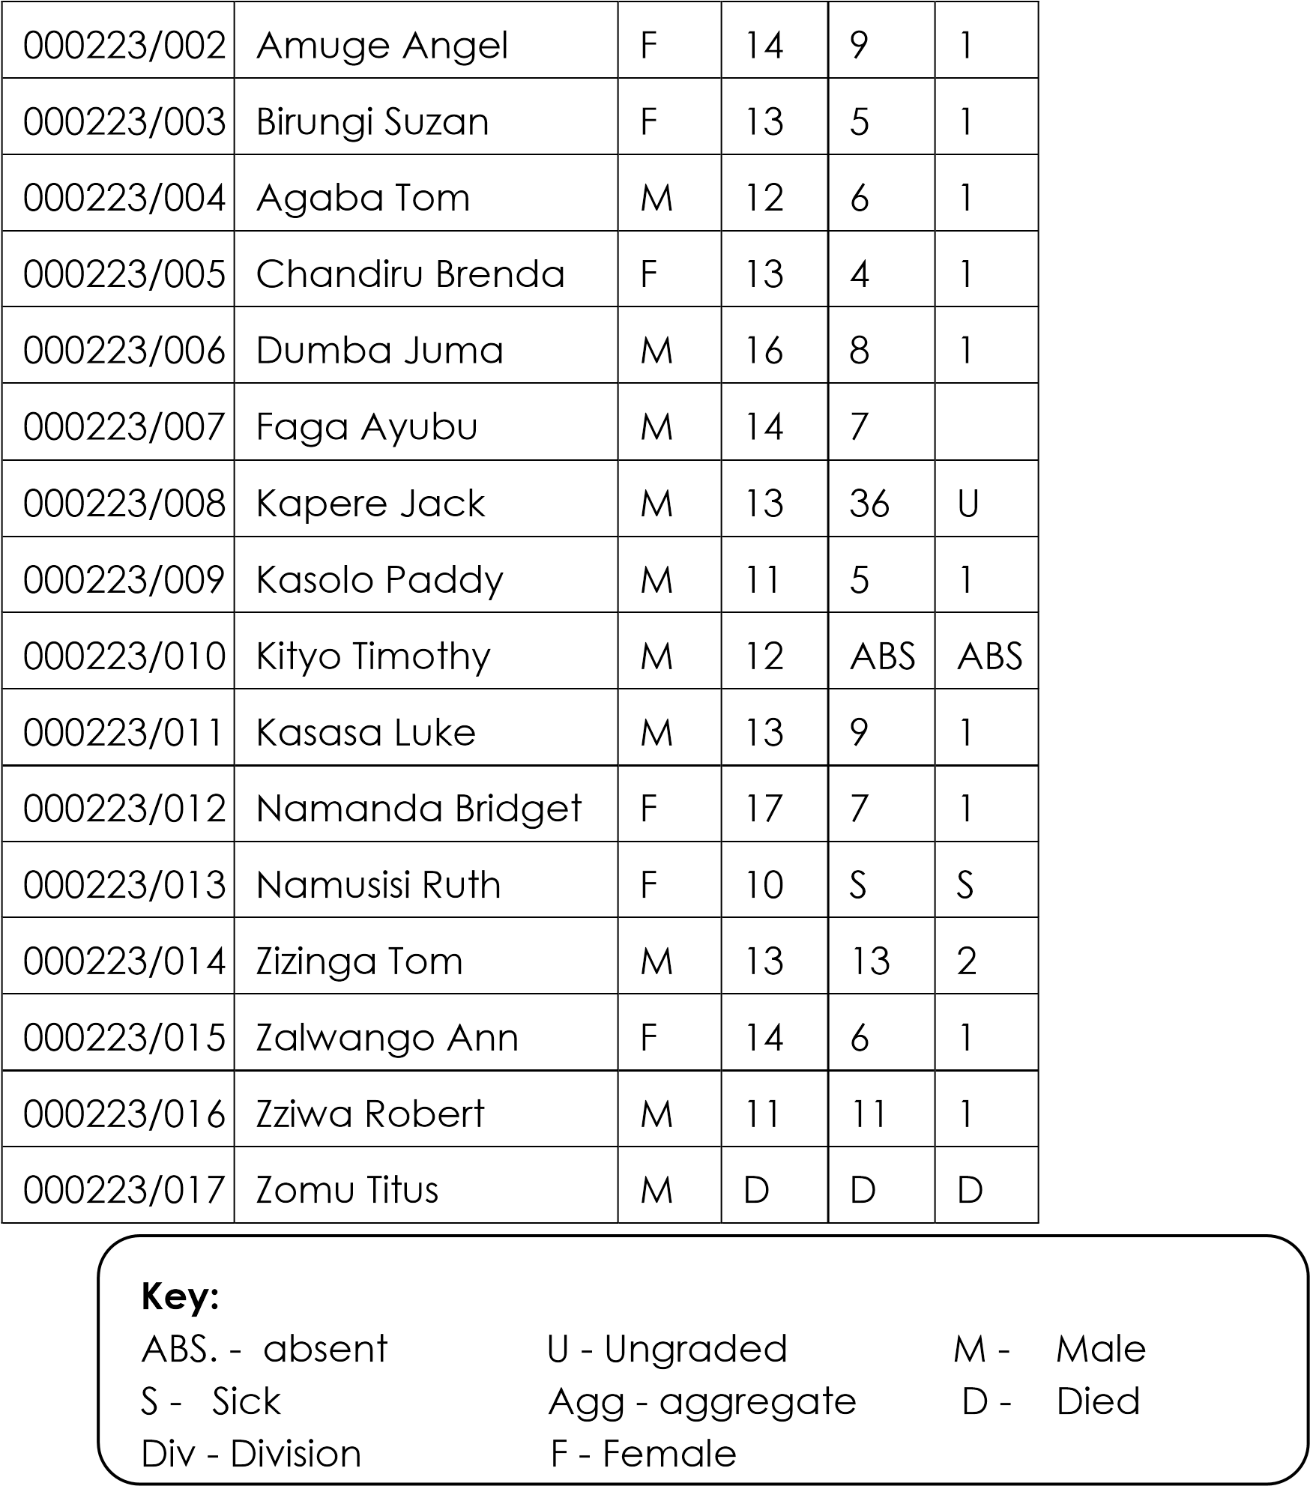

**Questions:**

1. What is the table about?
2. For which school are the above results?
3. How many candidates sat for the examination?
4. Who was the best candidate in the class?
5. How many candidates passed in division one?
6. How many candidates failed the examination?
7. Who was likely to repeat P.7?
8. Why did Kityo miss the examinations?
9. In which grade did Zizinga pass?
10. How old was Dumba?

**Graph**

Study the graph below carefully and answer the questions that follow in full sentences.

LANGO ROAD PRIMARY SCHOOL P.L.E RESULTS (Lira district)

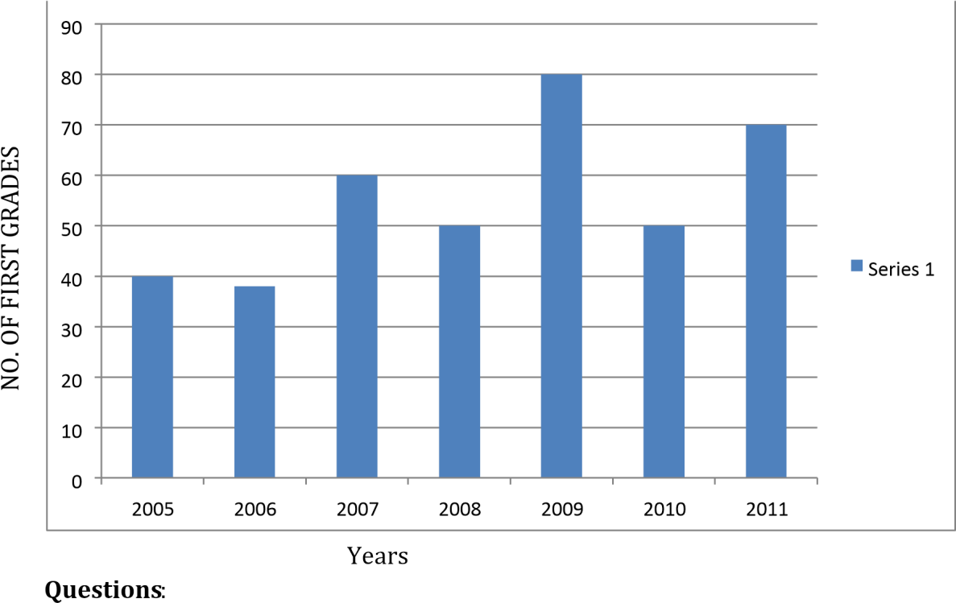

1. What is the information on the graph about?
2. For which school is the above information.
3. In which year did the school get thirty eight first grades?
4. How many first grades did the school score in 2007?
5. When do you think the candidates in the above school started sitting for P.L.E?
6. How many first graded were obtained between 2005 and 2008?
7. In which year did the school register the highest number of first grades?
8. When did the candidates score the least number of first grades?
9. What is the difference between the highest and lowest number of first grades?
10. Where is Lango Road primary school found?

**Picture composition.**

**The picture A-F tell a story. Study them and write one sentence to describe what is happening in each picture**.

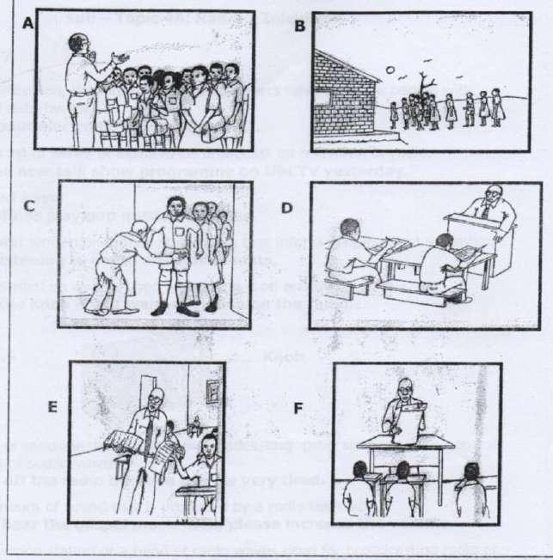

(



Lining up, Checking, invigilator, candidates, collecting, sealing,



envelope, taking, briefing, examination, examination room



Picture A .............................................................................................................................

Picture B .............................................................................................................................

Picture C ...........................................................................................................................

Picture D.............................................................................................................................

Picture E ............................................................................................................................... Picture F ...............................................................................................................................

1. Who might be checking the candidates in picture C?
2. Why did he check the candidates?
3. What is the invigilator doing in picture F?
4. Suggest a suitable title for this picture story?

**TOPIC 4: ELECTRONIC MEDIA**

**SUB- TOPIC 4A: RADIO / TELEVISION**

**Vocabulary**

**Mini-Dictionary**

**Media**: Radio, television, the internet and newspapers which provide people with information and entertainment.

We learnt about electronic media in term II.

**Programme**: A list or series of items to be broadcast on television or radio. I enjoyed the new talk show programme on UBC TV yesterday.

**Music**: Organise sound.

FM radio stations play pop music every day.

**announcements**: Written or spoken statements that inform people about something. I

don’t like listening to death announcement.

Knob: A round switch on a radio used for turning it on and off. Please turn the knob if you want to switch on the radio.

**Radio**: A device or machine that is used for broadcasting programmes to the general public by means of sound waves.

John turned off the radio because he was very tired.

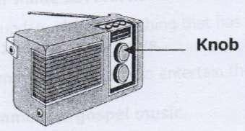

**Volume**: The amount of sound that is produced by a radio television. If you don’t hear the gospel music well, please increase the volume.

**Channel**: A television station or a band of radio waves used for broadcasting radio or TV programmes.

Whenever I want to listen to sports news, I select the sports channel.

**Speaker**: The part of a radio which the sound comes out of My uncle’s radio has two big speakers.

**Aerial**: Antenna or a metal rod for receiving or sending radio and television signals. Whenever I adjust the aerial, I get clear sound.

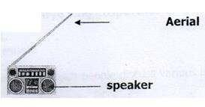

**Guide**: a table or line-up showing the time when different radio or television programmes will be broadcast.

According to the guide, the English news will be read at 9:00pm.

**Presenter**: A person who introduces the various television or radio programmes. Olanya Columus is a radio presenter.

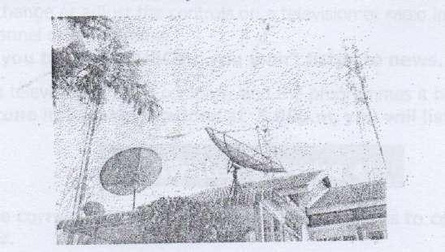

**Studio**: A room where television and radio programmes are recorded and broadcast.

As soon as we entered the radio studio, the power went off.

**Advert**: A notice, film or picture informing the public about a product, job or service. The campaign manager made several adverts on TV and radio.

**News**: New information or update about something that has happened recently. I like listening to the 10:00o’clock news.

**Entertainment**: Music, films or movies used to entertain the public on radio or television. Her favourite entertainment is gospel music.

**Broadcast**: To send out programmes on television or radio.

The independence anniversary celebration will be broad cast live on UBC TV.

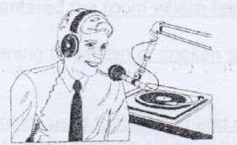

**Gospel music:** A style of religious singing.

Paster Wilson Bugembe and Judith Babirye sing gospel music.

**Pop**: Modern popular music of all sorts.

The youth enjoy listening to pop music.

**Talk** **show**. A radio or television programme in which people discuss various issues or topics.

Politicians and journalists enjoy talk shows.

**line**-**up**: A set of radio or television programmes arranged to follow one another. Gospel music comes after news according to the line-up.

**Forecast**: To predict what you think will happen in the future based on information available now.

The meteorologists forecast that it will rain tonight.

**Tune**: To change or adjust the controls on a television or radio in order to receive a certain channel or programme.

Unless you tune in to UBCTV, you won’t listen to news.

**Station**: A television or radio company and the programmes it broadcasts. It you

tune in to many stations at 5:00p.m, you will listen to sports news.

**EXERCISE**

(a) Use the correct form of the words in the brackets to complete the sentences.

1. The English news was ............................ by Bbaale Francis. (broadcast)
2. I like ...............................to gospel music on Sunday. (listen)
3. Babu is a good ...................... and so is Wava. (present)
4. If we tune in to supper FM, we ........................ to sports news. (enjoy)
5. It is expensive to make a death.......................... on television. (announce)
6. We listen to pop music on Radio Simba .................................. (day)

**b) Re-write the sentences giving a single word for the underlined group of words**.

1. The P.7 pupils entered the room where television programmes are recorded and broad cast.

_____________________________________________________________________________

1. Do you like listening to written or spoken statements that inform people about something?

_______________________________________________________________________________

1. He brought a device used for sending and receiving programmes that broadcast to the public through sound waves.

_______________________________________________________________________________

1. Abu Kyaze is a person who introduces various radio programmes.

_______________________________________________________________________________

**Language structures**

(a) If + present simple + shall / will + infinitive. **Example.**

1. Tune in to many stations at 5:00pm. You will listen to sports news.

If your tune in to many stations at 5:00pm, you will listen to sports news.

1. She will go to town. She is likely to buy a CD player.

**If she goes to town, she will buy a CD player.**

1. I shall get some money. I shall buy a radio.

**If I get some money, I shall buy a radio.**

**EXERCISE**

**Re-write the following sentences using: If.........................**

1. Musoke will listen to pop music when he tunes in to capital FM.

______________________________________________________________________________

1. I am likely to open up a radio station when I get money.

_______________________________________________________________________________

1. He will go to Kampala. He will visit Radio Simba.

_______________________________________________________________________________

1. When I see the manager, we shall have a talk show.

______________________________________________________________________________

1. Tune is to Top radio; you will listen to gospel music.

_______________________________________________________________________________

**b) ............................ and so....................**

**Re-write the following sentences using .........................and so..................................**  i. Joanita is a good presenter. Stecia is also a good presenter. **Joanita is a good presenter and so is Stecia.**

1. My father watched the football match. My mother watched the football match. **My father watched the football watch and so did any mother.**

1. WBS is a TV station. UBC is a TV station. **WBS is a TV station and so is UBC iv.**
2. The pupils will listen to gospel music. The teachers will listen to gospel music. **The pupil’s will listen to gospel music and so will the teachers.**
3. A radio station broadcasts news. A television broadcasts news. **A radio station broadcasts news and so does a television station.**

**EXERCISE**

**Re-write the following sentences using: ...................... and so .....................**

1. Bbaale reads news at 1:00pm. Mugisha reads news at 10:00pm.

_______________________________________________________________________________

1. Judith is a musician. Juliana is also a musician. _____________________________________________________________________________
2. Gospel music is interesting. Pop music is interesting.

____________________________________________________________________________________

1. Timothy has a radio. Isabirye also has a radio.

_______________________________________________________________________________ 5. The girls like music. The boys also like music.

_______________________________________________________________________________

6. Mary likes listening to gospel music. Nakato also likes listening to gospel music.

_______________________________________________________________________________

**c) .................................... and neither........................**

**Note.......................... and neither is used to join negative sentences.**  **Examples**:

1. Mr. Kule does not enjoy pop music. Mrs. Kule does not enjoy pop music.

**Mr. Kule does not enjoy pop music and neither does Mrs. Kule.**

1. Brenda is not a radio presenter. Kakuru is not a radio presenter. **Brenda is not a radio presenter and neither is Kakuru.**

1. You did not attend the talk show. Tom did not attend the talk show. **You did not attend the talk show and neither did Tom.**

**EXERCISE**

**Re-write the following sentences using............and neither .....................**

1. The presenter was not happy. The guest was not happy.

________________________________________________________________________________ 2. He did not broadcast the news. I did not broadcast the news.

________________________________________________________________________________ 3. Teddy is not a good presenter. Solome is not a good presenter.

________________________________________________________________________________ 4. The boys did not like the programme. The girls did not like the programme.

________________________________________________________________________________ 5. My niece did not listen to the death announcements. Your niece did not listen to the death announcements.

_______________________________________________________________________________

______________________________________________________________________________

6. Wasswa is not in the studio. Kato is not in the studio.

________________________________________________________________________________

**(d) I like..........................**

**Re-write the following sentences using: I like..........................**

**Examples:**

**Re-write the following sentences using ................... and neither.................**  i. I enjoy listening to pop music. **I like listening to pop music.**

1. Mary enjoys listening to sports news. **Mary likes listening to sports news.**

1. The enjoy tuning in to Uganda Broadcasting corporation.

**They like tuning in to Uganda Broadcasting Corporation.**

**EXERCISE**

**Re-write the following sentences using: I like.......................**

1. We enjoy listening to gospel music.

______________________________________________________________________________ 2. She enjoys watching side mirror.

______________________________________________________________________________ 3. They enjoy tuning in to local news.

______________________________________________________________________________ 4. She enjoys listening to weather forecast.

______________________________________________________________________________ 5. He enjoys listening to health tips.

______________________________________________________________________________

6. Children enjoy watching cartoons.

______________________________________________________________________________

**(e) I don’t like.............................................**

**Re-write the following using: I don’t like................................**  **Example**:

(i) I hate the sports programme.

**I don’t like the sports programme.**

1. We hate listening to death announcements.

**We don’t like listening to death announcements.**

1. John hates listening to gospel music.

**John doesn’t like listening to gospel music.**  **EXERCISE**

**Re-write the following sentences using: I don’t like..........................**

1. **I** hate tuning in to western music.

_______________________________________________________________________________ 2. We hate the new presenter.

_______________________________________________________________________________ 3. Peter hates the new programme.

_______________________________________________________________________________ 4. Children hate listening to talk show.

_______________________________________________________________________________

5. She hates tuning in to some FM stations.

_______________________________________________________________________________

**Comprehension:**

**A radio and television Programme Guide.**

**Below is a radio and TV programme guide for Sunday 6th May, 2015. Study it carefully and then answer the questions that follow in full sentences**.

|  |  |  |  |
| --- | --- | --- | --- |
| Time | Name of station | Programme | Presenter |
| 7:00-7:30am | WBS TV | Press digest | Diana Kagere |
| 8:00 – 9:00am | CAPITAL FM | Capital Gand | Olanya Columbus |
| 10:00-10:15am | UBC TV | English news | Bbaale Francis |
| 11:00- 12:00pm | TOP TV | Gospel music | - |
| 1:00 – 1:30pm | CBs FM | Luganda Music | Kasibante  Moses |
| 3:00 – 5:00pm | Super FM | Sports news | Mark Ssali |
| 5:00 – 6:00pm | UBC TV | Cartoons | - |
| 9:00 – 10:00pm | Bukedde TV | Omuntu w’abantu | Namitala  Bridget |
| 10:00 – 11:00pm | Bukedde TV | Agataliiko nfufu | Sanyu and  Kayira |
| 11:00 – 12:00am | WBS TV | Health zone | Prof. George  Kirya |

**QUIDING QUESTIONS**

1. What is the table about?

_______________________________________________________________________________ 2. Where can we find such information?

_______________________________________________________________________________ 3. How many TV stations are shown on the table?

_______________________________________________________________________________ 4. Who presents Health zone on WBS TV

_______________________________________________________________________________

1. How long is the sports programme on Super FM?

_______________________________________________________________________________

1. What are you likely to miss on Top TV if you turned in to WBS TV at 11:00 – 12:00pm?

_______________________________________________________________________________ 7. At what time is Luganda news broadcast on CBS FM?

_______________________________________________________________________________ 8. What are you likely to listen to your UBC TV between 10:00am and 10:15am?

_______________________________________________________________________________ 9. Write FM in full.

_______________________________________________________________________________

10. What programme do you think children enjoy most on UBC TV?

_______________________________________________________________________________

**Passage**

**Read the passage and answer the questions in full sentences.**  **The Greatest inventions in the world**.

There are several greatest inventions in the world. These inventions came as a result of the proverb “Necessity is the mother of invention” Therefore, the greatest men who are known as inventors came up with wonderful ideas.

The telephone is one of the greatest inventions in the world. The telephone was invented in American in 1876 by AG Bell. Nowadays people all over the world use telephones to make communication to relatives and pen-pals. another important invention was the aeroplane. The aeroplane was also invented in American by the Wright Brothers in 1903.

In 1912, Marconi invented the radio. The radio is used to broadcast different programmes by means of sound waves. Nowadays, there are various FM Radio stations in Uganda such Capital FM, CBS FM, Supper FM and many others. These FM radio stations have studios where radio programmes are recorded and broadcast. However, to be able to produce sound, radios use electricity or dry cells. Then the presenter use microphones and earphones.

Besides, the radio has different parts such as the buttons and knobs. The buttons are used to for switching the radio on and off whereas the knobs are used for tuning in to different stations. The knobs can also be used for reducing and increasing the volume. Radios provide entertainment, news, special announcement, adverts, pop music, sports news and gospel music to the public.

In 1926, the television was invented by J.L. Baird in England, Unlike the radio, the television produces sound as well as pictures. Nowadays, there are several television stations in Uganda. These include UBC, Top TV, WBS TV, NBS TV and NTV

**QUESTIONS:**

1. What is the passage about?

______________________________________________________________________________ 2. In which year was the radio invented?

______________________________________________________________________________ 3. Who invented the telephone?

______________________________________________________________________________ 4. Where was the television invented?

______________________________________________________________________________ 5. How many greatest inventions are mentioned in this passage?

______________________________________________________________________________ 6. Of what importance are radio station in a country?

______________________________________________________________________________

1. What do radio presenters use in the studios?

______________________________________________________________________________

1. Which programme is Malibu a sports fun likely to listen to?

______________________________________________________________________________

1. What did the Wright Brothers invent?

______________________________________________________________________________

1. Complete the proverb “Necessity”

______________________________________________________________________________

**Sub- topic 4B: Other electronic Media.**

**Vocabulary**

**Mini- Dictionary**.

**Eject**: To press a button or remote so as to get a tape or CD pushed out of the DVD player

or radio cassette.

When you want to remove or insert a CD, you must press the eject button.

**Aerial**: antenna or metal for receiving or sending radio and television signals. You must adjust the aerial in order to receive a clear picture.

**Guide**: A table or line-up showing the time when different radio or television programmes will be broadcast.

Radio and TV guide is published in the newspapers daily.

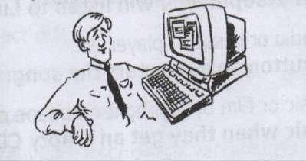

**Studio**: A room where television and radio programmes are recorded and broad cast. The talk show took place in WBS TV studio.

**Advert**: A notice, film or a picture telling the public about a product, job or service. There were a lot of adverts on UBC TV.

**Entertainment**: Music, films or movies used to entertain the public on radio or television.

Raid and television stations are a source of entertainment.

**CD**: A small disc on which sound or information is recorded.

A CD should be kept well and so should a DVD.

**DVD**: A disk on which large amounts of information especially photographs and video can be stored for use on a computer or DVD –player.

The film is available or DVD now.

**CD**-**ROM**: A CD on which large amount of information, sound and pictures can be stored for use on a computer.

The lake Kakoma’s biography is available on CD- ROM.

**CD** **RW**: a CD on which information, sound and pictures can be recorded and removed more than once.

The gospel songs were recorded on CD RW.

**Player**: A device or machine for reproducing sound or pictures that have been recorded on discs or cassettes.

Our neighbour bought a new DVD player.

**Recorder**: A device or machine for recording sound or pictures. If I had a lot of money, I would buy a video recorder.

**Disc**: A CD

Judith’s gospel music is now available on discs.

**Tape**: A long narrow strip of magnetic material which is used for recording sounds or information.

Her new song was recorded on tape or CD.

**The internet**: A system by which computers are connected through cables and telephone lines to provide useful information all over the world. The internet is an effective medium of communication.

**Video**: A copy of a film or programme which recorded on video tape. If my father gets money, he will buy a video tape.

**Tune**: To change or adjust the controls on a television or radio in order to receive a certain channel or programme.

If you tune into CBS FM at 2:00pm, you will listen to Luganda news.

**Press**: To push a button on a radio or cassette player etc.

The DJ pressed the play button so as to start the song.

**Record:** To make a copy of music or film by storing it on a tape or CD. They will record their music when they get an empty CD.

**Station**: A television or radio company and the programmes it broadcasts. The bank manager tuned into BBC to listen to world news.

**Connect:** To join together two or more things.

The internet is a system by which computers are connected through cables and telephones lines.

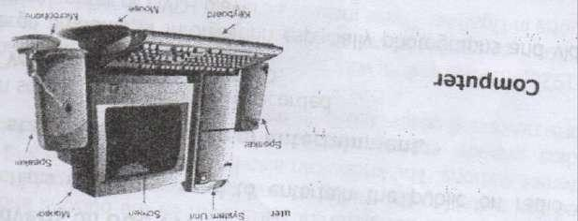

**Extension cable:** A wire, covered in plastic or rubber which carries electricity or telephone signals.

The computers are connected using extension cables.

**Volume;** The amount of sound that is produced by a radio or television. The teacher told me to reduce the volume because it was very high.

**Compact:** A device which is small and easy to carry.

The gospel music was recorded on compact.

**EXERCISE**

**Use the correct form of the words in brackets to complete the sentences**.

1. Mr. Musoke likes.............................. in to Top television. (tune)
2. Kato’s .................................. radio programme is news hour. (favour)
3. We....................................... two songs on CD yesterday. (record)
4. If I ........................... a lot of money, I would buy a DVD player. (have)
5. You needn’t have ............................ off the DVD because I was watching a nice film. (switch)
6. Electronic media provides us with .............................. (entertain)
7. If he had money, he .................................... a video recorder. (to buy)
8. He accidentally ......................................... the eject button and removed the CD. (press)
9. It was not necessary for you to switch off the TV because I was ............................. a movie. (watch)
10. Who has a tape.............................. at home? (record)

**Abbreviations:**

|  |  |  |
| --- | --- | --- |
|  | CD - | Compact disc |
|  | CDROM- | Compact disc read only memory |
|  | CD-RW - | Compact disc rewritable. |
|  | DVD - | Digital video disc/digital versatile disk. |
|  | Vol - | Volume |
|  | GB - | Gigabytes |
|  | RAM - | Random access memory |
|  | MHZ - | Megahertz |
|  | PC - | Personal computer |
|  | ROM - |  |
|  | SIM - |  |
|  | VTR - |  |
|  | HTTP – |  |
|  | SMS - |  |
|  | WWW - |  |
|  | URL - |  |
|  | CCTV – |  |
|  | FM - |  |
|  | DJ - |  |

 SW -  VJ -

**Language structures:**

**IF (2)**

**4B (a) IF + past simple + would/ could + infinitive**

**Examples.**

1. I don’t have money. I cannot buy a CD player. **If I had money, I would buy a CD player.**
2. I don’t have a CD player. I cannot buy many CDs.

**If I had a CD player, I would listen to pop music.**  iii. I don’t have time. I would listen to pop music. **If I had time, I would listen to pop music.**

**EXERCISE**

**Re-write the following sentences in if 2.**

1. Marion is likely to cry if she misses her programme.

_______________________________________________________________________________ 2. I don’t have a lot of money. I would record all the gospel music on one DVD.

___________________________________________________________________________________ 3. We don’t have a CD player so we cannot listen to pop music.

___________________________________________________________________________________ 4. If I go to town, I will buy a tape recorder.

___________________________________________________________________________________ 5. If I get a lot of money, I will set up a radio station.

___________________________________________________________________________________ 6. You cannot listen to music if you switch off the DVD.

___________________________________________________________________________________

7. I am not your brother; I would be a TV presenter.

___________________________________________________________________________________

b) ........................needn’t ..........................................

**Re-write the following sentences using ..................needn’t ..................**

**Examples**.

1. You ought not to have switched off the TV because I was watching the talk show.

**You needn’t have switched off the TV because I was watching the talk show.**

1. I ought not to have gone to the studio because I was not invited.

**I needn’t have gone to the studio because I was not invited.**

**EXERCISE**

**Re-Write the following sentences using ..................needn’t .........................**

1. Bob ought not to have gone to town because it was late.

___________________________________________________________________________________

1. The presenter shouldn’t have played gospel music at this time.

___________________________________________________________________________________

1. She ought not to have increased the volume because her father likes soft music.

___________________________________________________________________________________

1. They ought not to have switched off the television because their mother was listening to the news.

___________________________________________________________________________________

1. I shouldn’t have pressed the eject button because I was watching a nice film.

___________________________________________________________________________________

**(c) .............................. and so.......................**

**Re-write the following sentences using .......................and so..........................**

**Examples**

(i) A DVD should be kept well. A CD should be kept well.

A **DVD should be kept well and so should a CD.**

(ii) A radio should have an aerial. A television set should have an aerial.

A **radio should have an aerial and so should a television set.**

(iii) Television programmes should be educative, Radio programmes should be educative.

**Television programmes should be educative and so should the radio.**

**EXERCISE**

**Re-write the following sentences using ................and so..................**

1. Gospel music should be recorded. Pop music should be recorded.

_______________________________________________________________________________

1. Radio presenters should be polite. TV presenters should be polite.

_______________________________________________________________________________

1. DVDs should be durable. CDs should be durable.

______________________________________________________________________________

1. Babirye should buy a cassette recorder. Nakato should buy a cassette recorder.

______________________________________________________________________________

1. The tape recorder should be kept well. The video recorder should be kept well.

________________________________________________________________________________

1. A radio should be switched off . A television set should be switched off.

________________________________________________________________________________

**Passage**

Read the passage and answer the questions in full sentences.

**The internet.**

The internet is an international computer network connecting other networks and computers from companies, universities or organisations through an internet service provider. The internet service providers include; yahoo, Google, infocom, Gmail and hotmail

An internet service provider provides you with an internet connection and services such as surfing, logging and e-mail. E-mail is the short form of electronic mail.

Email addresses. An E-mail address consists of a service provider and the user’s name e.g. yigaali@google.com.ug.

In order for one to log in or on, one needs a password. The password allows one to begin using a computer system. At the internet cafe, one can have access to the internet explorer. This is a computer programme connected on the internet use for searching information.

Besides, one gets access to the search engine. A search engine is a computer programme that searches the internet for **data**, for example by looking for documents containing a particular word or a group of words from the data base. Data base is a store of information held in a computer. In order to access information, all one needs is to google. Google means to type words into a search engine on the internet in order to find information about something or somebody.

For example, job opportunities, educational, political, health or commercial issues. This service is used as a form of communication. For instance, once can chat with pen-pals, peers and colleagues. It also enables individuals, organizations, companies and the government to send and receive **essential** messages and information all over the world within a short period of time.

Furthermore, it reduces the costs and time that might have been spent for one to pay for air tickets to travel to different parts of the world in search of data.

Finally, the internet provides entertainment such as movies, sports news etc.

**Questions**:

1. What is the passage about?

______________________________________________________________________________ 2. How are the computers from companies connected?

______________________________________________________________________________ 3. Which people can one chat with through the internet?

______________________________________________________________________________

1. Write E-mail in full.

______________________________________________________________________________

1. What does one need in order to log in or out?

______________________________________________________________________________

1. Besides sports news, what else does the internet provide?

______________________________________________________________________________

1. Give another word or group of words with the same meaning as the following underlines words in the passages.

* data _________________________________________________________________________
* essential ______________________________________________________________________

1. What does an e-mail address consist of?

______________________________________________________________________________

1. How useful is a password?

______________________________________________________________________________ 10. What do you think an internet explorer is?

______________________________________________________________________________

**OTHER TOPICAL QUESTIONS**  **Advertisement**:

Read the advertisement below and answer the questions in full sentences.

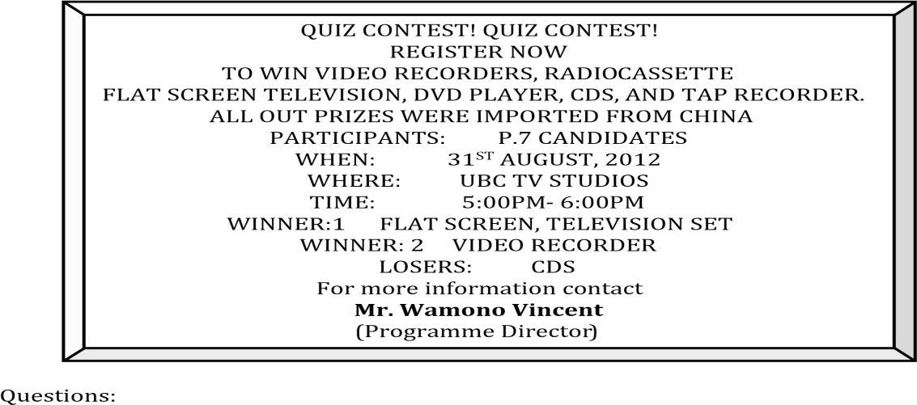

1. What is the notice about?
2. Who will participate in this quiz contest?
3. Where will the contest take place?
4. How long will the exercise last?
5. Who has organised the contest?
6. At what time will the contest begin?
7. Which prize will the first winner get?
8. Where were the prizes imported from?
9. When will the contest take place?
10. How can one join the contest

**Graph**

The graph below shows the number of people who use different electronic media in Uganda. Study it and answer the questions that follow in full sentences.

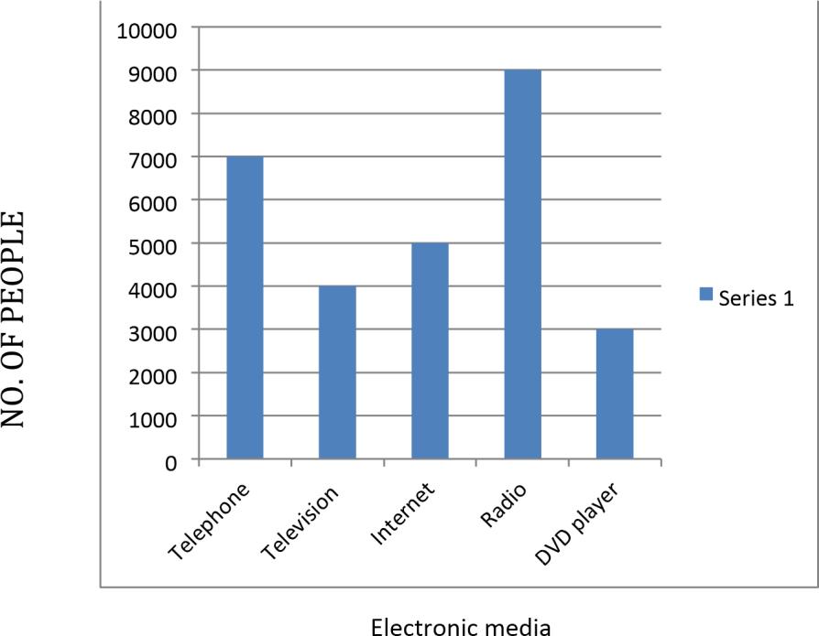

**Questions**:

1. What does the graph represent?
2. Which medium has the maximum number of users?
3. How many people use telephones according to the graph?
4. How many has the least number of people?
5. How many electronic media are represented on graph?
6. Which medium has got three thousand users?
7. How many people use the internet?
8. How many more people use the radio than the internet?
9. Which medium is used by four thousand people?
10. Write DVD in full.

**Guided composition.**

***The sentences below are in a wrong order. Re-arrange them so as to make a good composition about “Electronic Media”***

1. Men and women use telephones for sending and receiving messages.
2. Another electronic medium is the radio.
3. Some radios use dry cells while others use electricity.
4. There are several electronic media used in Uganda today.
5. Two kinds of telephones are used.
6. The commonest medium is the telephone.
7. Besides, other electronic media include the television and the internet.
8. However, to be able to use telephones, one needs airtime.
9. These are mobile phones and landlines or fixed lines.
10. A number of radio stations broadcast different programmes.

**TOPIC 5: RIGHTS, RESPONSIBILITIES AND FREEDOM**.

**Sub Topic 5A: Children’s Rights and responsibilities.**

**Vocabulary**

**Mini-Dictionary**

**Forced**: done or happening against somebody’s will Girls should not be forced to get married.

**Freedom**: the liberty or right to do or say what you wish without being stopped. Children must be given freedom.

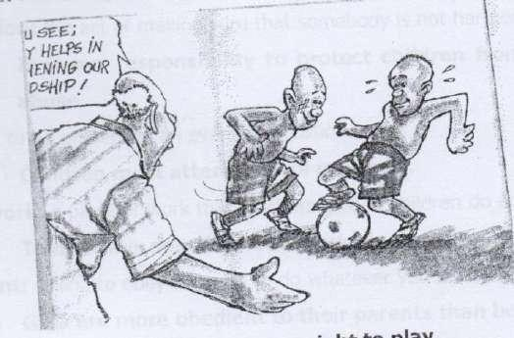

right: Moral or legal claims to get or have something.



Children have a right to education.



children have a right to play.

**Juvenile**: A young person who is not yet an adult.

Any person under eighteen years of age in Uganda is a juvenile.

**Food**: things which people or animals eat.

Children are entitled to food.

**Shelter**: A house or place to live in.

Children need clothing, food and shelter in order to lead a happy life. **Education**: A process of teaching, training and learning. Education and guidance are examples of children’s rights.

**Care**: Providing what somebody needs for their health or protection.

Both children and animals need medical care.

**Clothing**: Clothes or garments

All human beings need clothing as a basic need.

**Medication**: A drug or medicine that you take to prevent or treat an illness. We should not take any medication without the doctor’s prescription.

**Life**: The ability to breathe, grow or produce.

You should guard your life against diseases.

**Help**: assist

Good children help their parents with domestic work.

**Properly**: In a way that is socially or morally acceptable.

Parents should teach their children to behave properly.

**Work**: a duty or task.

Children must learn how to work.

**Protection**: The act of making sure that somebody is not harmed or injured.

It is our responsibility to protect children from violence and child abuse.

**Attend**: To be present at an event or occasion.

Children must attend school regularly.

**Homework**: A piece of work that teachers give to children to do at home.

Tom always does his homework always before he goes to bed.

**Obedient**: Willing to obey or ready to do whatever you are told.

Girls are more obedient to their parents than boys.

**Respect**: Polite behaviour towards somebody that you feel is important. Both boys and girls have a right to be treated with respect.

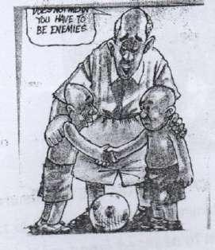

Children should respect each other.

**Refuse**: to say that you will not take or do something.

My step mother refused to give me food yesterday.

**Report**: To give information to somebody else.

It your rights are violated; you should report to police station or local council.

**Peace**: A period of time in which there is no violence or war.

We must always live in peace without neighbours.

**Grow**: To become bigger or taller and develop into an adult.

When my son grows up, he will become a lawyer.

**Clean**: Not dirty or to remove dirt.

He cleans his teeth every day.

**tidy**: Keeping neat and inorder. Our home is really very tidy.

**Responsible**: Having the duty of taking care of somebody or something. Asil is

a responsible child.

**Abuse**: To treat somebody in a cruel or violate way. *Children should not be abused of their rights*.

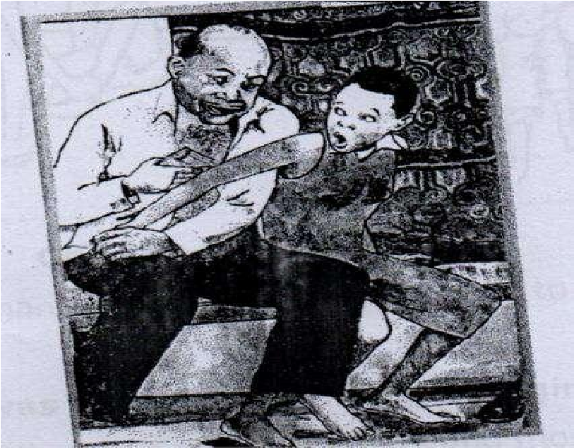

Girls should say No to money from sugar daddies.

**Mistreatment**: The act of treating a person or animals in a cruel or unfair way.

She ran away from home because of mistreatment by her step mother.

**Early** **marriage**: being married when still under age.

Parents should not force their daughters into early marriage.

**Convict**: To decide and say officially in a court of law that someone is guilty of a crime.

The sugar daddy was convicted of defilement.

**Imprison**: To put someone in prison.

The judge imprisoned him for child abuse.

**Innocent**: Not guilty of crime or not having done anything wrong. He was set free because he was innocent.

**Guilty**: Having done something against the law or illegal

Kajjubi was found guilty of murder and he was sentences to seven years in prison.

**Sentence**: A punishment given to someone by a court of law. If you mistreat your children, you will be given a heavy

**Crime**: an offence.

Child abuse is a crime.

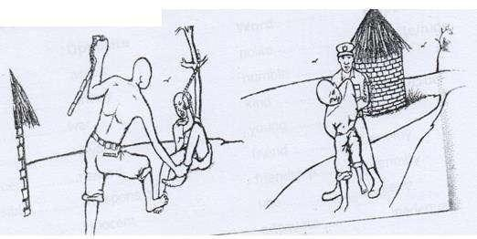

Child abuse is a bad act.

**Sugar daddy:** A rich older man who gives gifts and money to a much younger girl usually in return for sex.

**Sugar mummy:** A rich older woman who gives gifts and money to a much younger boy, usually in return for sex.

The police arrested a sugar mummy yesterday.

**Dropout:** To leave school before completing studies.

The introduction of Universal Primary Education helped to reduce the number of school dropout.

**Labour:** Physical work.

Child labour is punishable by law.

**Abortion**: A deliberate ending of a pregnancy at the early stage. Abortion is

a criminal act.

**Chores**: Tasks or tedious work that you do regularly.

Children should help their parents to do house chores.

**Criminal**: A person who has committed a crime.

The prison’s bus took the criminals to court.

**Opposites**

|  |  |
| --- | --- |
| **Word** | **Opposite** |
| Convict | acquit |
| tidy | untidy |
| peace | war |
| punish | reward |
| punishment | reward |
| responsible | irresponsible |
| guilty | innocent | |
| Sugar daddy | sugar  mummy | |
| polite | impolite/rude | |
| humble | proud | |
| kind | unkind/cruel | |
| young | old | |
| friend | enemy | |
| friendship | enmity | |
| late | early | |
| adequate | inadequate | |

**EXERCISE**

**(a) Use the correct form of the words in brackets to complete the sentence**

1. The ................................... was arrested by the local police. (crime)
2. Making wrong friends is ............................ to affect your studies. (like)
3. There was no ................................... in Musumba’s murder case. (prove)
4. ......................................... is a criminal act. (abort)
5. The old man was ........................... for child abuse. (prison)

**b) Fill the blank space with a suitable word.**

1. The woman ........................... daughter was defiled report the matter to police.
2. Musana was accused .................... stealing a hen.
3. The man ......................... raped a four-year-old girl was sentenced to death.

**(c) Re-write the sentence giving the opposite of the underlined word.**

1. The food you gave him as adequate.

______________________________________________________________________________

1. Most step mothers are cruel to their stepchildren.

___________________________________________________________________________________

**Language Structure:**

**(a) .................................. more interested in ................ than...............................**

**Re-write the following sentences using: More interested in than.................. Examples**.

1. Girls prefer cooking to playing.

**Girls are more interested in cooking than playing.**

1. Children prefer their parents to teachers. **Children prefer their parents to teachers.**
2. Boys prefer their rights to responsibilities.

**Boys are more interested in their rights than responsibilities.**   **EXERCISE**

**Re-write the following sentence using: more interested in ............. than.............**

1. Boys like football better than netball.

______________________________________________________________________________ 2. Parents like their children more than their neighbours.

______________________________________________________________________________

1. Children prefer love to hatred.

______________________________________________________________________________

1. Amos likes food better than medicine.

_______________________________________________________________________________ 5. My son likes sweeping the compound better than mopping the house.

_______________________________________________________________________________

1. Girls prefer ice cream to pancakes.

_______________________________________________________________________________

1. Fathers like their sons better than their daughters.

_______________________________________________________________________________

**(b) ..................... ought to ...............................**

1. Both boys and girls should go to school. Both boys and girls should go to school.

1. Parents should respect children’s right.

**Parents ought to respect children’s right.**

1. Children should be taught their responsibilities.  **Children ought to be taught their responsibilities.**

**EXERCISE**

**Re-write the following sentence using.......... ought to .......................**

1. All children should respect their parents.

_______________________________________________________________________________ 2. Both parent and teachers should protect children.

_______________________________________________________________________________

3. Girls and boys should help their parents. ___________________________________________________________________________________ 4. Children should have equal right.

_______________________________________________________________________________

5. Prefects should fight for their rights.

_______________________________________________________________________________

**EXERCISE**

**Re- write the following sentences using: more interested in .................... than............**

1. Boys like football better than netball.

_________________________________________________________________________________ 2. Parents like their children more than their neighbours.

_________________________________________________________________________________ 3. Children prefer love to hatred.

_________________________________________________________________________________ 4. Amos like food better than medicine.

_________________________________________________________________________________ 5. My son likes sweeping the compound better than mopping the house.

_________________________________________________________________________________

6. Girls prefer ice cream to pancakes.

_________________________________________________________________________________

**(b) ...................... ought to ...........................**

**Re-write the following sentences using .....................ought to ..........................**

1. Both boys and girls should go to school.

**Both boys and girls ought to go to school.**

1. Parents should respect children’s rights.

**Parents ought to respect children’s rights.**

1. Children should be taught their responsibilities.

**Children ought to be taught their responsibilities.**

**EXERCISE**

**Re-write the following sentences using.................... ought to .......................**

1. All children should respect their parents.

_______________________________________________________________________________ 2. Both parents and teachers should protect children.

_______________________________________________________________________________ 3. Girls and boys should help their parents.

_______________________________________________________________________________

4. Children should have equal rights. ___________________________________________________________________________________ 5. Prefects should fight for their rights.

_______________________________________________________________________________

6. Sugar daddies should be imprisoned.

_______________________________________________________________________________

**(c) ...............................ought not to .........................**

Re-write the following sentences using......................ought not to ........................ **Examples**.

1. Parents should not abuse their children.

**Parents ought not to abuse their children.**

1. Step mothers should not mistreat their step children.  **Step mothers ought not to mistreat their step children.**

**EXERCISE**

1. Children should not disobey their teachers and parents.

_______________________________________________________________________________ 2. Girls should not do abortion because it is dangerous to their lives.

_______________________________________________________________________________ 3. Boys should not mistreat animals because they are our friends.

_______________________________________________________________________________ 4. Parents should not force their daughters into marriage.

_______________________________________________________________________________

5. One should not over work oneself in any job.

_______________________________________________________________________________

**(d) .....................in order to .......................**

**In order to have the same meaning as ‘so as to’**

**Re-write the following sentences using: ........................ in order ................**  **Examples**

1. You should always name in groups so as avoid being abducted.  **You should always move in groups in order to avoid being abducted.**

1. Children should always say no to bad touches so as to avoid children abuse.

**Children should always say no to bad touches in order to avoid children abuse.**

1. Teachers should always encourage girls to keep in school so as to reduce school dropout.

**Teachers should always encourage girls to keep in school in order to reduce school**

**dropout.**

**EXERCISE**

**Re-write the following sentences using...................in order to......................**

1. We should always feed our children well so as to keep them healthy

_________________________________________________________________________________

1. You should always report wrong doers to police so as to avoid children abuse. _________________________________________________________________________________
2. Girls should always say no to gifts so as to avoid sugar daddies.

_________________________________________________________________________________

1. Girls should always keep in school so as to avoid early marriage.

_________________________________________________________________________________

1. All children should always be given freedom so as to avoid street children.

_________________________________________________________________________________

1. Children should be taken to school so as to get education.

_________________________________________________________________________________

1. Pupils should be taught their rights so as to live a happy life.

_________________________________________________________________________________

1. Parents should take care of their children to avoid child abuse.

_________________________________________________________________________________

**(e) ...................either............................or.................................**

Either .........................or can be used at the beginning or middle of the sentence.

**Re-write the following sentences using: .......................either...............or.......................**

**Examples**.

1. You provide food to your children. You risk going to prison.

**You either provide food to your children or you risk going to prison.**

1. The step mother will be arrested. The step father will be arrested. **Either the step mother or the step father will be arrested.**

**EXERCISE**

1. The street children should be given food. The street children should be given clothes.

_______________________________________________________________________________ _______________________________________________________________________________ 2. The sugar daddies will be imprisoned. The sugar mummies will be imprisoned.

_______________________________________________________________________________ 3. Your mother is innocent. Your father is innocent.

_______________________________________________________________________________ 4. You take your children to school. You will be arrested.

_______________________________________________________________________________

5. James guilty. You will be sentenced to life imprisonment.

_______________________________________________________________________________

**(f) ............................... is likely to ..........................................**

**Re- write the following sentences using......................... is likely to .......................................**

**EXAMPLES**

1. Making wrong friends may affect your studies.

**Making wrong friends is likely to affect your studies.**

1. Mistreating children may force them to go on the streets.  **Mistreating children is likely to force them to go on the streets.**

1. Corporal punishments may increase the number of school dropout.

**Corporal punishments are likely to increase the number of school dropout.**  **EXERCISE**

1. Forcing young girls into marriage may affect their future.

_______________________________________________________________________________ 2. Protecting children may make their lives happy.

_______________________________________________________________________________ 3. Feeding children may improve their health.

_______________________________________________________________________________ 4. Educating both boys and girls may reduce illiteracy.

_______________________________________________________________________________

5. Denying children food may cause death.

_______________________________________________________________________________

**Passage**

**Reading the passage below and answer the questions that follow in full sentences**.

**Children’s rights and responsibilities**.

Children have various rights and responsibilities at home or at school. According to the children’s statute 1996, a child is any person under eighteen years of age.

Children’s rights include the right to food, clothing, shelter, medical care, education and guidance. In addition, children are entitled to live with their biological parents or guardians. Children also have right to play.

The statute also states that children should be protected from all forms of violence abuse, neglect and social discrimination. Children should, therefore have freedom of speech, worship or association.

Similarly, no child shall be employed or engaged in any activity that may be harmful to his or her welfare, health education, physical, mental or moral development to avoid child labour. All children ought to go to school irrespective or regardless of their gender or sex.

Besides their rights, children have a number of responsibilities at home or in society. Children must help their parents or guardians to do house chores such as fetching water, peeling, cooking, washing utensils etc. It is therefore, the responsibility of both parents and guardians to teach their children acceptable behaviour in society for instance, worshipping, greeting elders and attending social or cultural ceremonies like weddings and burial.

At school, teachers must help children to learn the school daily routines like sweeping, doing class work by putting time tables and sweeping rosters. If this is done, there is no doubt that children will understand their rights and responsibilities hence live harmoniously with others and reduce the rampant child abuse in our communities.

**Questions**:

1. What is the passage about?

_______________________________________________________________________________

1. Who is a child according to the passage?

_______________________________________________________________________________

1. When was the children’s stature publish?

_______________________________________________________________________________

1. Write down any two children’s rights in this passage.

(i)_____________________________________________________________________________ (ii) _________________________________________________________________________________

1. Give anyone responsibility of a child at home.

_______________________________________________________________________________

1. What is rampant in our community nowadays according to the passage?

_______________________________________________________________________________

1. Give another or group of words with the same meaning as the underlined words in the passage.

(i) Various................................................................................................................................. (ii) Besides.................................................................................................................................

8. Why do you think children should not be employed?

_______________________________________________________________________________

**Guided** **composition**

**The sentences below are in wrong order. Re-arrange them in correct order so as to make a good composition about “A TORTURED ORPHHAN”**

1. At the police station Bridget’s aunt made a statement.
2. Within a period of twenty four hours, the suspect was taken to court.
3. In court, the judge convicted Bridget’s aunt of the crime.
4. Bridget went to the nearest police station and reported the matter.
5. He therefore sentenced her to five years in prison for torturing an innocent orphan.
6. Bridget is a twelve year old orphan.
7. One day Bridget’s aunt tortured her.
8. And then took her to the police station.
9. She lives with her aunt at Naguru.
10. The police came and arrested her aunt.

_______________________________________________________________________

_______________________________________________________________________

_______________________________________________________________________

_______________________________________________________________________

_______________________________________________________________________

_______________________________________________________________________

_______________________________________________________________________

_______________________________________________________________________

_______________________________________________________________________

_______________________________________________________________________

_______________________________________________________________________

_______________________________________________________________________

_______________________________________________________________________

_______________________________________________________________________

_______________________________________________________________________

**OTHER QUIDING QUESTIONS**

**Dialogue:**

**1. Read the following and answer the questions that follow in full sentences**

**CHILD ABUSE:**

**Police officer**: How do you do, little girl!

**Cathy**: How do you do, officer!

**Police officer**: How can I help you, please?

**Cathy**: I have come to report a certain crime.

**Police officer**: What is the crime?

**Cathy**: It’s child abuse.

**Police officer**: What is it exactly?

**Cathy**: Our neighbour usually mistreats his children. He denies them food, clothing, shelter and doesn’t allow them to go school to get education.

**Police officer**: Oh no! All children have a right to food, clothing, shelter and education.

**Cathy**. Besides, he forces young girls into early marriage because he wants bride price and dowry. In my opinion, this practice and mistreatment must stop now. The police is requested to rescue the innocent children.

**Police officer**: You are right. The police will arrest and prosecute the suspect. If he is proved guilty, he will be charged and imprisoned for at least three months.

**Cathy:** I hope if this step is taken, it will help to reduce the rate o child abuse in our community. Goodbye officer.

**Questions:**

1. What is the dialogue about?
2. How many people took part in the dialogue?
3. Where do you think this dialogue took place?
4. Why did Cathy go to the police station?
5. How does Cathy’s neighbour mistreat his children?
6. What is the police requested to do?
7. What will happen if the suspected is found guilty?
8. For how long will the criminal be imprisoned?
9. Give another word or group of words with the same meaning as the underlined words in the dialogue.
10. crime
11. practice

Give the opposite of innocent

**2.Read the passage below and answer the questions that follow in full sentences**.

It was Friday morning when all the pupils of Katwe Primary School had gathered for their routine assembly. They were eager to listen to the speeches from different speakers such as prefect, the teacher on- duty and headteacher.

This time the Headteacher, Mr. George, invited a police officer to address children about how to protect themselves from rape and defilement. First of all, the police officer, Corporal Mugyenyi Ambrose, defined the terms rap and defilement. He said,” Rape refers to using violence or force in order to have sex with a girl or a woman. The rapist may be a known person or stranger to the victim.

In addition, he defined defilement as the act of having sexual intercourse with a girl who

is still under the age of eighteen years.

After defining the terms, the police officer advised pupils to take not of the following points; to say no to gifts from sugar daddies, the girl MUST scream or make an alarm for help.

Children should say no to bad touches in private body parts like breasts and hips. In case one tries to rape or defile a girl, the girl MUST scream or make an alarm for help. Children should avoid going to dark or isolated places because it is risky. He also encouraged children always to move in groups to avoid child abuse.

A child who has been raped or defiled MUST be immediately taken for a medical checkup. Neither the victim nor her clothes MUST be washed before reporting the matter to court. He warned parents and teachers against blaming a defiled or raped girl since most of the time they are **innocent**.

Finally, the police officer told us that a victim of rape of defilement needs comfort and counselling to prevent stigma. By the end of the assembly, the pupils had learnt a lot about rape and defilement. Kato the head prefect was requested by the teacher – onduty to give a vote of thanks to the police officer for the educate assembly he had conducted.

Questions:

1. Who was the teacher-on-duty?
2. On which day was the assembly organized?
3. What was the name of the police office?
4. Why was the police officer invited?
5. What did the police officer advice the children to do?
6. What shouldn’t a parent or guardian do when a child is raped?
7. Why is it not necessary to blame a child who has been raped?
8. What was Kato told to do according to the passage?
9. What is defilement according to this passage?
10. Suggest a suitable title for this passage.

**3.The notice below was written on the local council I office of Mirembe village. Study it carefully and answer the questions in full sentences.**

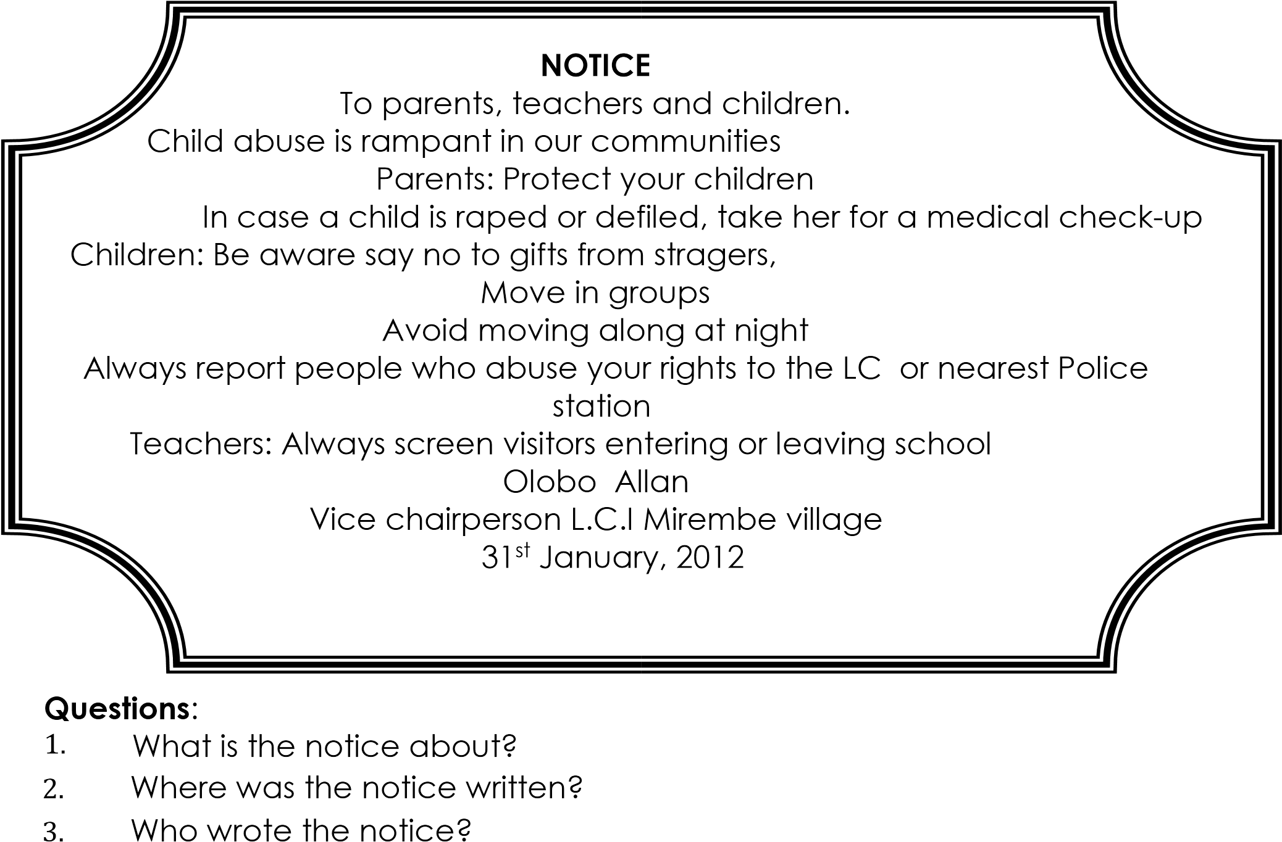

1. What are parents advised to do?
2. Where should the children report people who violate their rights?
3. When was the notice written?
4. Why do you think the vice chairperson LC.1 made this notice?
5. What are teachers likely to do to avoid child abuse at school?
6. Write in full: L.C..............................
7. How can the children avoid child abuse?

**Poem:**

**4.Read the following poem and answer the questions in full sentences.**  **Leave me alone sugar daddy**.

Dear sugar daddy; Why don’t you leave me alone?

Why do you give me sweets and gifts? Is it because you want me to love you,

Make me pregnant and abandon me by the roadside?

Dear sugar daddy;

Why do you violate my rights?

Why do you want me to drop out of school?

Why don’t you leave me to get education?

Don’t you have your wife at home?

Dear sugar daddy;

I still need care and protection, Just like your own daughter,

But why do you pester me to love you, As if I were your age mate?

Dear sugar daddy;

Please be patient with me; You are very old and I am very young; Why don’t you have pity on me!

By: Baby Patra.

**Questions:**

1. Who is speaking in the poem?
2. To whom is the writer speaking?
3. Does the writer go to school or not?
4. Why do you think the writer goes to school?
5. What does the sugar daddy give to the writer in stanza one?
6. Who is the poetess?
7. How many stanzas does the poem have?
8. What does the writer need in stanza three?
9. Give one word or a group of words with the same meaning as the following words in the poem; abandon; ........................ violate; ...................................
10. What is likely to happen to the writer if she accepts the sugar daddy’s gifts?

5.**Poem:**

**Read the poem and answer the questions that follows in full sentences**.

Defilement! Defilement! Defilement!

What a dangerous vice you are!

In homes, schools, churches, mosques, courts.

Everywhere people talk about you.

Sugar daddies and mummies,

Trick innocent girls and boys, With sweets, money and other gifts, Oh! What a serious crime this is!

Sugar daddies and mummies,

Why do you infect innocent children,?

With HIV AIDS

Why don’t you have mercy?

Young girls and boys,

Guard your lives against these ruthless men and women,

Say No to sweets, money gifts and lifts, Say No to bad touches, avoid risks to stay safer!

By Allen Kagina.

**Questions:**

1. What is the poem about?
2. How do defilers trick young girls and boys?
3. Who defiles children according to the poem?
4. What does the writer advise the young girls and boys to do?
5. What does the writer call defilement in this poem?
6. What advice would you give to sugar daddies and mummies?
7. Why do you think defilement is bad?
8. Mention on place where defilement is talked about?
9. Give another word or a group of words with the same meaning as crime..........
10. Suggest a suitable title for this poem.

**6.Guided composition**.

Below is a dialogue between Simon and Luuze. What Luuze said is given. Complete the dialogue by filling in, what do you thing were Simon’s correct response.

Luuze: You look un happy, Simon. What is the matter?

Simon: I .....................................................................................................................................

Luuze: Why did you run away from home?

Simon: 2 ....................................................................................................................................

Luuze: Why did you fight with your sister?

Simon: 3 ....................................................................................................................................

Luuze: She ate your cake! Did you report the matter to you parents?

Simon: 4 ....................................................................................................................................

Luuze: Why didn’t you report her to your parents?

Simon:5 ....................................................................................................................................

Luuze: You feared them! Do your parents mistreat you?

Simon: 6 ....................................................................................................................................

Luuze: Simon, you are really telling a lie.

Simon: 7 ....................................................................................................................................

Luuze: Thank you Simon for admitting your mistake.

Simon:8 ....................................................................................................................................

Luuze: Replying your parents rudely is bad.

Simon: 9 ....................................................................................................................................

Luuze: You must go to your parents and apologize.

Simon:10 ....................................................................................................................................

Luuze: Yes, they will forgive you and allow you to return home.

**Picture Story:**

**The picture A- F tell a story. Study them and write one sentence to describe what is**

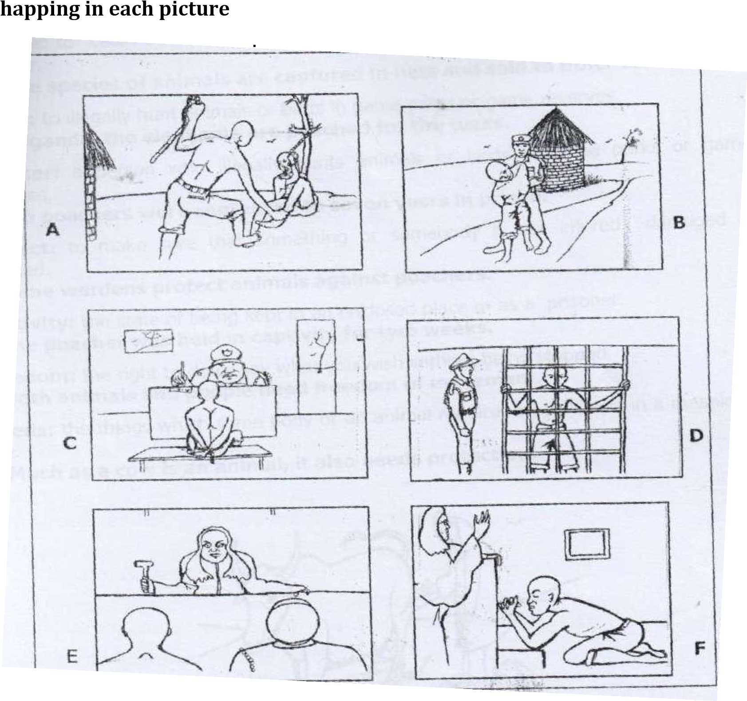

(Judge, torturing, child, pleading, police station, arresting, man)

Picture A ....................................

Picture B ...................................

Picture C ...................................

Picture D ....................................

Picture E ...................................

Picture F ....................................

1. Where is the man in picture D?
2. Why is the man pleading with the judge?
3. Who arrested the man in picture B?
4. Give a suitable title to this story?

**SUB-TOPIC 5B: ANIMAL NEEDS AND FREEDOMS.**

**VOCABULARY:**

**MINI-DICTIONARY**

**Capture**: To catch on animal or person and keep them in an enclosed space or as a prisoner.

Some species of animals are captured in nets and sold to other countries, **poach:** To illegally hunt animals or birds in game parts or game reserves. In Uganda, the elephants are poached for the tusks.

**Poacher**: A person who illegally hunts animals or birds in game parks or game reserves. Two poachers were sentenced to seven years in prison.

**Protect**: To make sure that something or somebody is not injured damaged or harmed. Game wardens protect animals against poachers.

**Captivity**: The state of being kept in an enclosed place or as a prisoner. The poacher

was held in captivity for two weeks.

**Freedom**: The right to do or say what you wish without being stopped. Both animals and people need freedom of movement.

**Needs**: The things which some body or an animal requires so as to live in a meaningful life.

Much as a cow is an animal, it also needs protection.

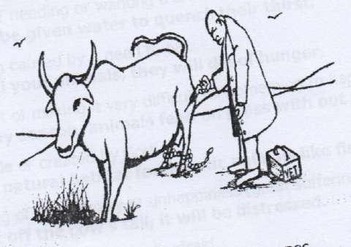

**Reproduction**: The process or act of producing young ones.

The farmers studied about reproduction in cattle.

**Responsibilities**: Tasks, roles or duties to take care of something.

Children must understand their rights and responsibilities in society.

**Insemination**: The act of putting sperms into a female animal in order to make it pregnant.

Artificial insemination helps to improve the bread of cattle.

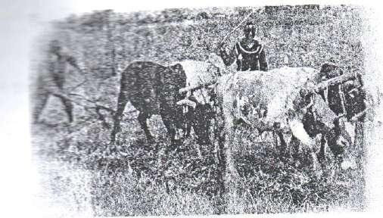

Oxen ploughing



**Discomfort**: A feeling of slight pain or of being physically uncomfortable. Animals usually experience severe discomfort during the dry season.

**Injury**: harm done to an animal’s or person’s body.

My cow and its calf sustained minor injuries when they fell into a pit latrine.

**Secure**: Feeling happy and confident about yourself or a particular place.

Domestic animals feel secure when they are not tortured.

**Torture**: To hurt or cause severe pain to someone or animal.

The youth must not torture animals because they are their friends.

**Tease**: To annoy an animal by touching or pulling its ears or tail.

It is not good to tease a dog because it may bite you.

**Thirst**: The feeling of needing or wanting a drink.

Animals should be given water to quench their thirst.

**Hunger**: The feeling caused by a need to eat.

If you don’t feed your animals, they will die of hunger.

**Hindrance**: the act of making it very difficult for something to happen.

During the rainy season, animals feed on grass without any hindrance.

**Natural**: God made or created by God.

Wetlands are natural habitat for aquatic animals like fish.

**Distress**: A feeling of great worry or unhappiness (great suffering) When you cut off the cow’s tail, it will be distressed.

**Frighten**: to scare or make some body afraid.

The barking dogs frightened the children at the farm.

**Sanctuary**: A place where wild birds or animals are protected and left to breed. There are a lot of flamingos and ostriches at the wild life sanctuary.

**EXERCISE**

**(a) Give the plural form of these words**.

1. Fox .....................................
2. ostrich ……………….............
3. flamingo ....................

**(b)** Rewrite the sentences giving the opposite of the underlined word.

1. Some wild animals are secure these days.

_______________________________________________________________________________

1. Animals need discomfort.

_______________________________________________________________________________ 7. The cows were given a lot of water.

_______________________________________________________________________________

**Use the correct form of words in the brackets to complete the sentences.**

8. The poacher was held in .......................... for two weeks. (capture)

_______________________________________________________________________________ 9. Both animals and people need ........................... of movement. (free)

_______________________________________________________________________________ 10. The farmers studied about ................................ in cattle. (reproduce)

_______________________________________________________________________________

**Language structures:**

**(a) Much as ..................................**

**Re-write the following sentences using: Much as .............................**

**Examples**

1. A cow is an animal. It also needs protection.

**Much as a cow is an animal, it also needs protection.**

1. A sheep is an animal. It also needs water.

**Much as a sheep is an animal, it also needs water.**

1. A dog is an animal. It also needs freedom.

**Much as a dog is an animal. It also needs freedom.**

**EXERCISE**

1. A monkey is an animal. It also needs security.

_______________________________________________________________________________

1. A rabbit is animal. It also needs security.

_______________________________________________________________________________

1. A goat is an animal. It also needs shelter.

_______________________________________________________________________________

1. A cat is an animal. It also needs freedom.

_________________________________________________________________________________

1. A donkey is an animal. It also needs rest. ______________________________________________________________________________
2. An elephant is a wild animal. It also needs protection.

_________________________________________________________________________________

(**b) ......................need not have...................**

**Re-write the following sentences using .....................need not have...................**  **Examples:**

1. Mugisha should not have tied his goat to his bicycle carrier.

**Mugisha need not have tied his goat to the bicycle carrier.**

1. The farmer ought not have docked his sheep.

**The farmer need not have docked his sheep.**

**EXERCISE**

1. You should not have slaughtered a sick cow.

_______________________________________________________________________________

1. Farmers ought not to have dipped their calves.

_______________________________________________________________________________

1. Obote should not have tortured his domestic animals.

_______________________________________________________________________________

1. The cyclist should not have tied the hens to the motorcycle carrier.

_______________________________________________________________________________

1. The old man ought not to have sold all his cows.

_______________________________________________________________________________

**(c) Whereas........................**

**Re-write the following sentences beginning: whereas................................................**

1. Children want their right. They do no respect animals right.

**Whereas children want their rights, they do not respect animal rights.**

1. Hunters want to eat meat. They do not want to keep domestic animals.

**Whereas hunters want to eat meat, they do not want to keep domestic animals.**

1. John wants milk. He does not want to look after his father’s cows.

**Whereas John wants milk, he does not want to look after his father’s cows.**

**EXERCISE**

**Re-write the given sentences beginning. Whereas ...............................**

1. The farmer wants healthy animals. He does not want to feed them well.

_______________________________________________________________________________

1. People want their rights. They do not respect animal freedoms. ______________________________________________________________________________
2. Kapere admires rabbits. He does not want to rear them at his home.

_______________________________________________________________________________

1. Mrs. Kasujja wants eggs. She does not want to keep hens.

_______________________________________________________________________________

1. Oboth wants medical care. He does not want to treat his animals.

_______________________________________________________________________________ **Abbreviations and acronyms related to animal welfare.**

ABS ......................... Animal Behavior society.

ADI ........................Animal Defenders International.

ASAB ......................... Association for the Study of Animal Behavior.

AVAR ....................... Association for Veterinarians for Animal Rights.

CAPS ....................... Captive Animals Protection Society.

NEMA ...................... National Environment Management Authority.

USPS ....................... Uganda Society for the Protection of Animals.

UWA ....................... Uganda wildlife Authority

UWEC .................... Uganda Wild Life Education Centre.

VET ....................... Veterinarian

WCU......................Wildlife Clubs of Uganda.

WSPA ................. World Society for the Protection of Animals.

**Read the page and answer the questions in full sentences.**  **ANIMALS LIFE**:

Animals have life like human beings. They also need shelter, water, food and medical care. A person who treats sick animals is called a Veterinarian.

There are two types of animals in Uganda. Some animals live with people at home while others live in the bushes or forests. The animals which live with people at home are referred to as domestic animals. These include sheep, goats, donkeys, camels, rabbits, cows and dogs. In history, the dog was the first animal to be tamed by man. it helps man in hunting and guarding homes.

People get milk, meat, skins and hides from the animals which live at home. Some animals which are kept at home help to do domestic work. For instance, camels and donkeys are used for transport. Oxen are used for ploughing.

The animals which live in the bushes and forests are; lions, monkey, hyenas, buffaloes etc. some of the wild animals are kept in the zoos or game parks for study purposes and tourist attraction. People who visit animals in the zoo or game parks are called tourists. they pay money to see wild animals.

Finally, certain species of birds are kept in sanctuaries. These include flamingos, ostriches, crested, marobstock etc.

**GUIDING QUESTIONS**:

1. What is the passage about?

______________________________________________________________________________

1. How many types of animals are in Uganda?

______________________________________________________________________________ 3. What do we call animals kept at home?

______________________________________________________________________________ 4. Which type of animals live in the forests?

______________________________________________________________________________ 5. Why do we keep animals at home?

______________________________________________________________________________ 6. What was the first animal to be tamed by man?

______________________________________________________________________________ 7. Give one example of wild animals.

______________________________________________________________________________ 8. Which animals are used for transport according to the passage?

______________________________________________________________________________ 9. What are oxen used for?

______________________________________________________________________________

10. Who is a veterinarian?

______________________________________________________________________________

**Guided composition.**

**Read the passage and fill in the blank spaces with the missing words from the list.** **Animal Needs and Freedoms.**

Our teacher taught us about ........................ needs and freedoms last term. Like people,

animals too need medication, ........................... food and water to quench their

..................... He emphasized the ............................... of respecting and caring for animals.

One of the things he told us was much as a cow is an animal, it also need

........................... He also told us that whereas people want their rights they do not respect animals ........................... He therefore warned us against .............................. both domestic and wild animals because it distresses them. “Domestic and wild animals feel

............................... when they are tortured,” he said.

In addition, he said that it is very dangerous to tease a dog because it may ................. you. He concluded that game wardens must protect animals in game parks against

.................

They must understand that wildlife attracts tourist to our country.

Bit, poachers, importance, insecure, shelter, animal, freedoms, torturing, thirst, protection.

**Picture composition.**

The picture A to F tell a story. Study them carefully and then write one sentence to describe what is happening in each picture. You may use the following words to help you.

**Herdsman, grazing, looking after, herd of cattle, borehole, drinking, milking, milk can, calf, veterinarian, sick, treating, wearing, gumboots, kraal, docking, syringe**.

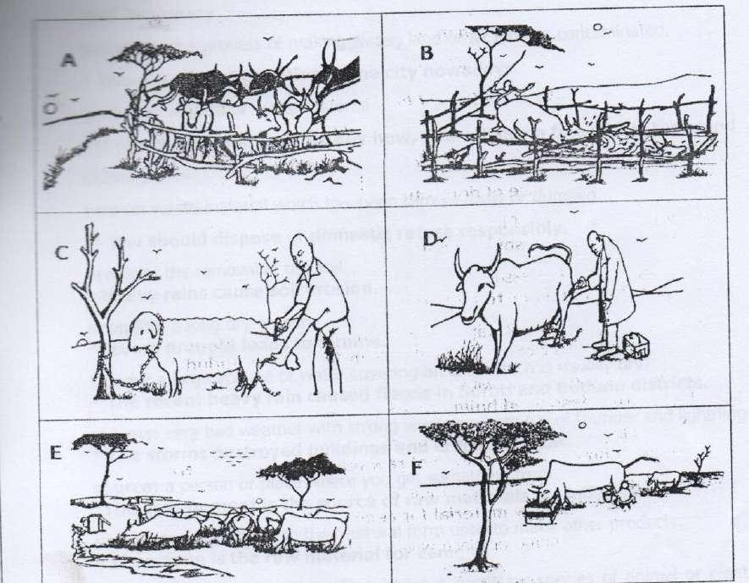

1. Picture A ..........................................................................................................................
2. Picture B: ..............................................................................................................................
3. Picture C .............................................................................................................................. (d) Picture D

..................................................................................................................................

(e) PictureE ............................................................................................................................... (f) PictureF ...............................................................................................................................

(g) Why is the vet, officer docking the sheep in picture C? ___________________________________________________________________________________ (h) What is the farmer doing in picture B?

_________________________________________________________________________________ (i) What did the vet, officer use to treat the sick animal?

_________________________________________________________________________________ (j) Suggest a suitable title for this story.

_________________________________________________________________________________